King’s Business School, King’s College London

Cover Sheet for SINE DIGITAL / MSc DMK Consultancy Project 24/25

Candidate ID: | AF30241  AF16719  AF31230  AF03399  AF26857
Module Code: | 7QQMM530  7QQMM531  7QQMM532  7QQMM538
Module Name: | JOINT SINE DIGITAL / MSC DMK CONSULTANCY PROJECT
Word Count: | 4393

Please complete the above candidate and module information and attach to the front of your answer sheet/submission or write your answers on the following page(s).

Where applicable students should clearly state the question(s) they are answering (e.g. Question 1, Part A) so it can be clearly identified for markers.

DECLARATION BY STUDENT

I understand what is meant by plagiarism/collusion and have signed at enrolment the declaration concerning the avoidance of plagiarism/collusion.

I understand that plagiarism and collusion is a serious examinations offence that may result in disciplinary action being taken.

I understand that I must submit work BEFORE the deadline, and that failure to do so may result in late submission penalties.

I understand that where a word limit is indicated, I should adhere to the word limit and failure to do so may result in penalties.

I understand that King's requires students to acknowledge any use of generative AI tools in coursework. Please select and complete the applicable statement and provide additional information where required.

2. I declare that parts of this submission has contributions from AI software and that it aligns with acceptable use as specified as part of the assignment brief/ guidance and is consistent with good academic practice. The content can still be considered as my own words. I understand that as long as my use falls within the scope of appropriate use as defined in the assessment brief/guidance then this declaration will not have any direct impact on the grades awarded.

I acknowledge use of software to [include only the statements which apply, and provide details as appropriate]:

(iii) Generate some other aspect of the submitted assessment.

[Extension of ChatGPT Dall-E (https://chatgpt.com) has been used to generate the persona images from detailed persona descriptions, TikTok storyboard campaigns, video campaigns and mock-ups of demonstrations of advertisements in cinemas and on public transport.]

By completing this assessment, you acknowledge that you have read and understand the above. Please do not sign your name.

Table of Contents

Section 1. Digital Marketing Strategy 6
Part A: Benchmark RBO against competitors 6
Part B: RBO’s existing value proposition 10
Part C: Recommendations on the future of RBO value proposition 13
Section 2. Research in Marketing 15
Part A: Research Aim and Objectives 15
Part B: Research design and methodology 16
Part C: Sampling methods and data collection 17
Part D: Data analysis and interpretation 18
Part E: Key conclusions and recommendations 46
Section 3. Digital Consumer Behaviour 48
Part A: Identifying RBO’s Target Market 48
Part B: Target Market Segment: Global Majority Audiences and Lower-income Households 50
Part C: Decision-Making Process of Each Target 53
Section 4. Digital Marketing Communications 56
Part A: Campaign Objective and Message 56
Part B: Creative Campaign Execution and Media Channels 58
Reference List 61
Appendices 74
Appendix A: Competitor Benchmarking Table 74
Appendix B: Mock-ups of offline media 75
Appendix C: Storyboard of a TikTok Influencer 77
Appendix D: Consumer Persona Profiles 78
Appendix E: Measures and Measurements Table 88
Appendix F: Questionnaire Preview 89
Appendix G: Interview Guide 90
Appendix H: Posts to Advertise for Survey/Interview Participants. 94
Appendix I: JASP Outputs 95
Appendix J: Storyboard for Video Campaign 96
Appendix K: Social Media Mock-up 98
Appendix L: Cinema Ad Mock-up 99
Appendix M: Image Campaign 100
Appendix N: Market Positioning Table 103

Section 1. Digital Marketing Strategy

Part A: Benchmark RBO against competitors

 | Royal Ballet and Opera | English National Opera | Metropolitan Opera | West End Theatre | Sydney Opera House
Core offerings | Live performances at Covent Garden, accompanied by digital content like screenings and behind-the-scenes videos. | Large-scale opera performances, ENO Orchestra, and a range of programs like ENO Screen and ENO TV. | Grand productions with a full orchestra, costumes, and multi-language performances. | High-quality musicals and plays, appealing to families and tourists. | Variety of performances, including opera, ballet, and theatre.
Target Market | Primarily 45+ with disposable income, but recent efforts target 18-35-year-olds and families, aiming to engage a younger, diverse demographic. | Traditional operagoers (50+), Millennial and Gen Z audiences, families, and educational institutions. | Primarily 45+, with a secondary focus on 18–34-year-olds. | Ages 25-54, families, and culturally diverse London audiences. | Tourists, families, and local art patrons.
Digital Presence | Multi-tiered to balance exclusivity with accessibility, offering discounts for students and young adults, rush tickets, and affordable seating options. | Active on social media and offers live streaming. | Extensive, with HD broadcasts and online content. | Engages via social media with updates and behind-the-scenes content. | Online tours, VR experiences, and streaming.
Pricing structure | Multi-tiered to balance exclusivity with accessibility, offering discounts for students and young adults, rush tickets, and affordable seating options. | Flexible, with discounts for younger audiences and free tickets for under 21s. | Tiered to cater to both high-income patrons and budget-sensitive audiences. | Flexible, with discounts for young audiences and family packages. | Tiered ticketing from AUD 50-350, plus guided tours.
Revenue Model | Ticket sales, memberships, donations, and digital revenue from live streams. | Ticket sales, donations, and digital subscriptions. | Driven by ticket sales, donations, and streaming services. | Ticket sales and merchandise. | Ticket sales, venue rentals, and merchandise.
Value Proposition | RBO promotes both traditional performances and digital innovation to attract new and diverse audiences, enhancing accessibility to opera and ballet. | Makes opera accessible with a focus on affordability and inclusivity. | Combines tradition with modern accessibility through initiatives like "Live in HD." | A hub for diverse cultural experiences. | Cultural landmark showcasing local and international talent.
Engagement | Uses social media to share interactive content and increase brand visibility; targeted efforts to build loyalty through exclusive membership benefits | Strong online presence with content like behind-the-scenes videos. | Promotes accessibility and inclusivity through youth programs and diverse productions. | Promotes diversity and offers online booking and social media engagement. | Strong focus on accessibility and sustainability.
Table 1: Summary bullet points of the competitive benchmarking table for the report
(See Appendix A for full benchmarking table)

In today’s industry, The Royal Ballet Opera (RBO) stands out through a combination of traditional appeal and digital accessibility. Compared to competitors like the English National Opera (ENO), The Metropolitan Opera (The Met), The Sydney Opera House, and West End Theatres, RBO’s strengths and opportunities are evident through seven competitive factors: Pricing, core marketing, brand perception, digital offerings, value proposition, community, and inclusivity.
Core marketing offerings form RBO’s highlights live performances supported by digital screenings. This reflects worldwide patterns; institutions like The Met use expansive cinema transmissions, making performances accessible worldwide (Metropolitan Opera, 2024). Competitors like Sydney Opera House and West End Theatres have a variety of musicals, plays, and workshops, suggesting opportunities for RBO to expand programming (Appendix A).
In terms of brand perception, RBO positions itself as a preserver of classical arts, similar to ENO’s emphasis on being “The opera company for everyone” (English National Opera, 2024). Studies highlight the importance of inclusivity in shifting opera from an elite art to a more accessible cultural experience (Hill et al, 2023).
RBO’s digital offerings include performances on socials, enhancing reach among younger, international audiences. However, The Met’s comprehensive digital presence and on-demand streaming set a high standard, suggesting RBO could benefit from exclusive digital content (Appendix A). Literature supports digital presence as a driver of accessibility and revenue (Colbert, 2003).
Like ENO, RBO's value proposition combines traditional performances with contemporary digital access (English National Opera, 2024). According to arts management studies, this appeals to loyal customers and new audiences (Byrnes, 2009).
Community engagement is still essential for RBO's membership programs, offering exclusive access and discounts. Sydney Opera House’s community involvement could inspire RBO to enhance community ties and membership perks (Appendix A).
Finally, RBO offers a variety of different prices from expensive sears to reasonably priced digital options. ENO’s discounted ticket programs for younger audiences is an example of how RBO can attract younger audiences (Kotler & Scheff, 1997). Through these strategies, RBO competes effectively while maintaining room to grow (Appendix N).

Part B: RBO’s existing value proposition

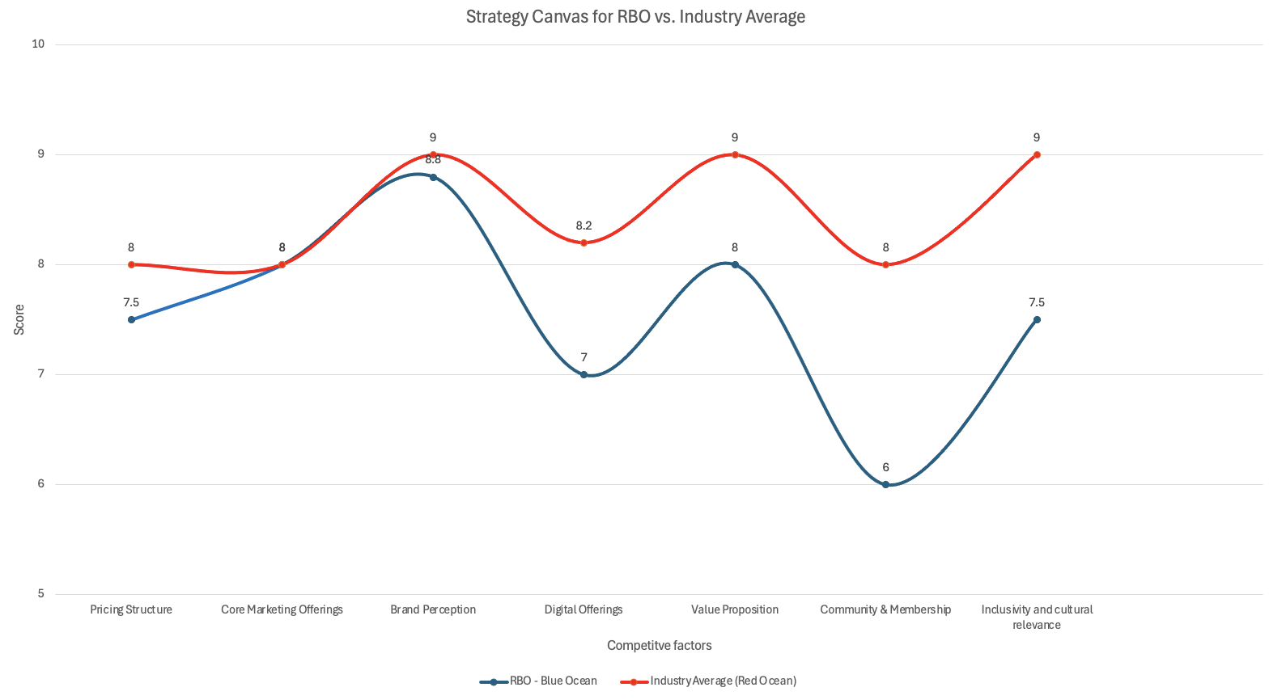
Figure 1: Current Strategy Canvas: The current strategy canvas compares The Royal Ballet and Opera performance to the industry average across key competitive factors. These insights highlight the areas in which RBO can focus on improvement.

The Royal Ballet Opera House holds a premium position in the performing arts industry. Despite strong branding and quality offerings, RBO faces challenges with inclusivity, digital engagement, and pricing. This places them below the industry average, suggesting opportunities for growth and innovation.
RBO’s core marketing offerings are a strength. The institution delivers high-quality productions, reinforcing its premium position. This focus on excellence has established a loyal customer base and sustained its reputation as a leading arts institution. Additionally, RBO’s membership programs offer benefits like discounted tickets and exclusive access to performances. These initiatives strengthen loyalty and enhance brand perception.
RBO’s high brand perception, though prestigious, might generate a negative image due to its elitist nature, making it seem unapproachable. RBO can implement initiatives to make the brand more inclusive.
With a pricing structure below the industry average, RBO faces challenges. High prices for live performances prevent wider audience reach. Even with pricing alternatives like the ‘Young RBO scheme,’ budget-conscious customers may turn to competitors offering more affordable tiers with better benefits.
RBO has embraced digital engagement through live streaming and interactive content. However, its digital platforms, particularly mobile functionality, lag behind the industry average. Poor mobile integration may negatively impact user experiences like ticket booking. RBO should invest in digital infrastructure to meet younger, tech-savvy audience expectations.
Cultural relevance and inclusivity remain shortcomings. Although RBO has outreach initiatives and flexible pricing, it is still regarded as an elitist art form. Current efforts limit RBO from engaging modern, diverse communities, holding them back from connecting with audiences prioritising culturally relevant, inclusive experiences.
RBO’s community-building and membership programs lack inclusivity and engagement with broader audiences. Engagement with casual viewers and digital-only consumers is limited since traditional perks, like discounted in-person tickets, do not apply. Despite RBO attracting younger, tech-savvy audiences through social platforms, membership offerings lack virtual and flexible options.
With RBO’s strong foundation in core offerings and brand reception, long-term viability depends on a strategic approach combining creative, inclusive, and accessible efforts with current offerings. This will allow RBO to connect with broader audiences and restore relevance in this competitive industry.
Eliminate | Raise
- Digital offerings
- Value proposition
- Community and memberships
- Inclusivity
Reduce | Create
- Brand perceptions | - Cultural integration

Figure 1a: Four action frameworks: Provides a strategic approach for The Royal Ballet and Opera to redefine it’s value proposition

Part C: Recommendations on the future of RBO value proposition

The proposed strategy for RBO stems from primary data, including interviews and survey results. The four actions framework offers a clear pathway for RBO to achieve its primary objective: ensuring diverse representation across media and effectively engaging its target audience of 18–25-year-olds (Kim and Mauborgne, 2015).
To reduce negative brand perception, advertising on traditional media channels enables RBO to focus on stronger visibility with urban advertising in busy areas like buses and underground stations (Appendix B). Enhancing presence on these platforms will soften RBO's elitist perception. By increasing perception factors in the strategy canvas, RBO's brand will appear more approachable.
To enhance its marketing position and reach a wider audience, RBO should raise digital offerings and value propositions through inclusivity, fostering community, increasing memberships, and improving brand perception. Better digital products, like interactive streaming, will draw younger and international viewers. Audience loyalty will grow if the value proposition is strengthened with unique experiences such as pre-performance discussions and ‘day in the life’ features relatable to the audience (Appendix C). Younger audiences are likely to view RBO positively, shifting from elitism to modernity and approachability.

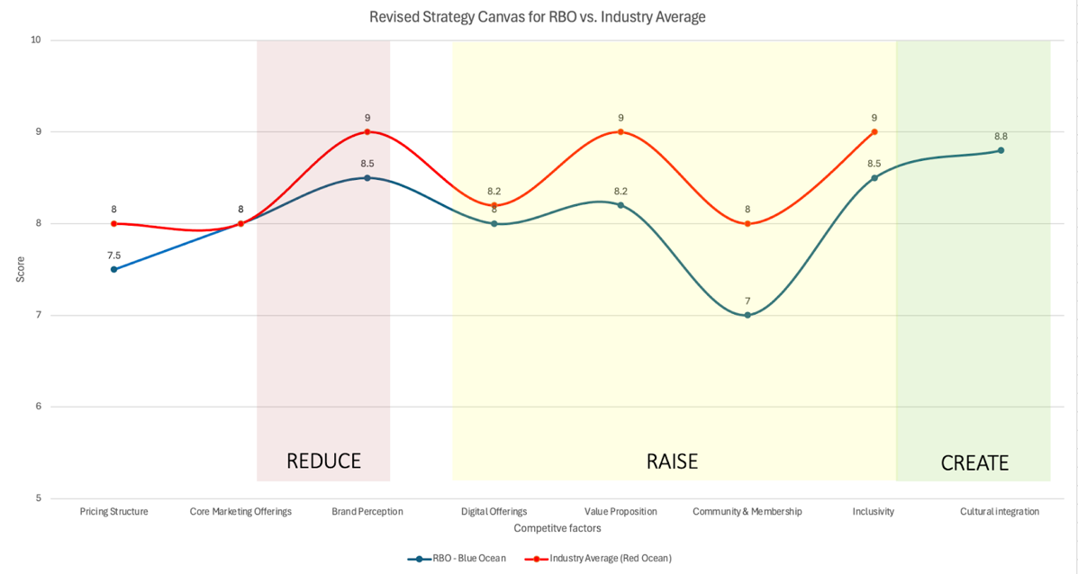
Figure 1b: Revised Strategy Canvas: The revised strategy canvas illustrates the positive impact resulting from the implementations of our primary strategic recommendation.

Creating cultural integration is our main strategic approach, encompassed within all campaigns, including video, photo, and social.
To reach younger, varied audiences, RBO must reduce perceptions of opera and ballet as elite and exclusive. Embracing cultural diversity in advertisements enhances their reputation as a progressive institution (Peracchio et al., 2014). Raising diverse representation across multimedia content will increase RBO’s inclusivity and cultural relevance (Appendix D).
Our final campaign focuses on featuring artists from underrepresented backgrounds and global narratives that resonate with multicultural identities. The customer's journey starts with curiosity, followed by intent, and fosters belonging, creating repeat customers and an emotional bond (Maslow, 1943). Doing so will position RBO as a cultural advocacy leader and ensure young individuals resonate with them, gaining a competitive edge.

Section 2. Research in Marketing

Part A: Research Aim and Objectives

To increase brand awareness and change brand perceptions to attract new audiences, especially younger groups, we conducted market research for this purpose. The research aims to evaluate the awareness and familiarity with the Royal Ballet and Opera (RBO) among younger audiences (18-25 years). Another aim is to identify audience associations and perceptions of RBO. Through market research, it provides a reference for the client’s future engagement and strategy development.

For quantitative research, the research questions are:
- To what extent are younger audiences aware of RBO and its offerings?
- What are the general brand associations of the target audiences with RBO?

The research questions for the qualitative approach are:
- What are the target audience’s perceptions and salient brand associations with RBO?
- How do target audiences describe their attitudes and potential barriers to participation in RBO?

Part B: Research design and methodology

For this research, the exploratory research approach was considered appropriate. Exploratory research helps to investigate young audiences’ general perceptions of RBO and to identify key factors without pre-set expectations. A descriptive research design was also used to measure the young audience’s awareness of RBO.
This research adopts a mixed-methods approach, combining qualitative and quantitative research to comprehensively understand brand awareness and perceptions of RBO among young audiences. The quantitative survey is one of the primary data collection methods used to measure awareness, familiarity and general brand associations with RBO. The questionnaire was designed using a combination of closed-ended questions and Likert scales (measures and measurements are attached in Appendix E).
Furthermore, qualitative interviews provide deeper insights into perceptions to obtain more detailed or overlooked information. Semi-structured interviews were used in this research because of their flexibility and to identify new concepts (Dearnley, 2005). This combined approach improves the research’s comprehensiveness and depth, effectively understanding the complexities behind young audiences’ perceptions of RBO. The questionnaire design and interview guide are attached in Appendix F and Appendix G.

Part C: Sampling methods and data collection

This study used a non-probability Convenience Sampling technique to reach the target audience of young adults. This technique is appropriate due to time and budget constraints (Etikan et al., 2016, cited in Battaglia, 2008). For the quantitative survey, online recruitment via social media can reach a diverse range of young individuals, increasing accessibility and cost-efficiency. For qualitative interviews, we recruited social media posters and asked friends and family to find participants who matched the target audience and were willing to participate (posts to advertise interview see Appendix H). This convenience-oriented approach improves accessibility for participants.

Part D: Data analysis and interpretation

This study used JASP to test collected data. Initially, a total of 206 responses were collected. After excluding invalid data (participants who selected “no” in the Consent question and participants who did not fully complete the questionnaire), 138 valid responses were collected. Since the research focused primarily on the 18-25 age group audience, finally, the number of valid responses collected was 108.

D.1 Demographic Profile

We collected data from audiences aged 18-25 (N=108) through an online questionnaire. Based on the data we collected from our sample (see Table 1):

Table 1. Sample Data
Items | Classification | Frequency | Percent
 |  |  | (%)
Gender | Male | 20 | 18.52
 | Female | 82 | 75.93
 | Non-binary / third gender | 2 | 1.85
 | Prefer not to say | 4 | 3.70
Age | 18-25 | 108 | 100.00
(Continues on next page)

Accommodation | UK | 49 | 45.37
 | Europe | 15 | 13.89
 | Asia | 32 | 29.63
 | Africa | 1 | 0.93
 | North and South America | 5 | 4.63
 | Australia | 6 | 5.56
Employment status | Employed for wages | 14 | 12.96
 | Self-employed | 10 | 9.26
 | Out of work and looking for work | 6 | 5.56
 | Out of work but not currently looking for work | 4 | 3.70
 | A student | 73 | 67.59
 | Unable to work | 1 | 0.93
Total |  | 108 | 100.00
20 male, 82 female, two non-binary/third gender and 4 ‘prefer not to say’ participants; all are aged 18-25 years (100%); 45.37% are accommodated in the UK and the remaining 54.63% are in other countries; 12.96% were Employed for wages，9.26% Self-employed，5.56% Out of work and looking for work，3.7% Out of work but not currently looking for work，67.59% students and 0.93% Unable to work.

Accommodation | UK | 49 | 45.37
 | Europe | 15 | 13.89
 | Asia | 32 | 29.63
 | Africa | 1 | 0.93
 | North and South America | 5 | 4.63
 | Australia | 6 | 5.56
Employment status | Employed for wages | 14 | 12.96
 | Self-employed | 10 | 9.26
 | Out of work and looking for work | 6 | 5.56
 | Out of work but not currently looking for work | 4 | 3.70
 | A student | 73 | 67.59
 | Unable to work | 1 | 0.93
Total |  | 108 | 100.00
20 male, 82 female, two non-binary/third gender and 4 ‘prefer not to say’ participants; all are aged 18-25 years (100%); 45.37% are accommodated in the UK and the remaining 54.63% are in other countries; 12.96% were Employed for wages，9.26% Self-employed，5.56% Out of work and looking for work，3.7% Out of work but not currently looking for work，67.59% students and 0.93% Unable to work.

D.2 Reliability Test

In Table 2, the Cronbach’s Alpha values for all variables were greater than 0.7, so the internal consistency of the scales was good.

Table 2. Summary of Reliability Test
Variables | N of Items | Cronbach’s Alpha
A Q2 | 3 | 0.845
B Q1 | 3 | 0.761
B Q3 | 4 | 0.767
C Q5 | 4 | 0.855
D Q1 | 3 | 0.740
D Q2 | 3 | 0.741
E Q1 | 4 | 0.834
A Q2 = Familiarity; B Q1 = Customer Satisfaction; B Q3 = Website Perceptions; C Q5 = Firm-created Social Media Communication; D Q1 = Brand Affordability; D Q2 = Attitude toward the Loyalty Programme; E Q1 = Perceived Similarity
In reliability testing, the α value must be greater than 0.7 to indicate internal consistency of the scale.

D.3 Validity

In validity assessment, the results in Table 3 showed good performances.
Table 3. Measurement items, RC1, CR and AVE
Variables | Items | RC1 | CR | AVE
A Q2 | A Q2_1 | 0.892 | 0.907 | 0.764
 | A Q2_2 | 0.877
 | A Q2_3 | 0.853
B Q1 | B Q1_1 | 0.782 | 0.872 | 0.695
 | B Q1_2 | 0.924
 | B Q1_3 | 0.788
B Q3 | B Q3_1 | 0.761 | 0.855 | 0.597
 | B Q3_2 | 0.652
 | B Q3_3 | 0.865
 | B Q3_4 | 0.798
C Q5 | C Q5_1 | 0.809 | 0.902 | 0.698
 | C Q5_2 | 0.856
 | C Q5_3 | 0.853
 | C Q5_4 | 0.822
(Continues on next page)

D Q1 | D Q1_1 | 0.845 | 0.853 | 0.659
 | D Q1_2 | 0.752
 | D Q1_3 | 0.835
D Q2 | D Q2_1 | 0.802 | 0.853 | 0.660
 | D Q2_2 | 0.851
 | D Q2_3 | 0.783
E Q1 | E Q1_1 | 0.823 | 0.891 | 0.672
 | E Q1_2 | 0.876
 | E Q1_3 | 0.833
 | E Q1_4 | 0.740
A Q2 = Familiarity; B Q1 = Customer Satisfaction; B Q3 = Website Perceptions; C Q5 = Firm-created Social Media Communication; D Q1 = Brand Affordability; D Q2 = Attitude toward the Loyalty Programme; E Q1 = Perceived Similarity
In this research, RC1 had to be greater than 0.7, the AVE value should be higher than 0.50 to confirm validity, and composite reliability (CR) should be higher than 0.70 to confirm reliability.

D.4 Descriptive analysis

About familiarity (see Table 4), we divided the audience’s familiarity with RBO into two groups (1=familiar; 0=not familiar). By calculating the average of the three items, those less than or equal to 4 are unfamiliar and those greater than 4 are familiar. Overall, 50 are 0 (unfamiliar) and 58 are 1 (familiar).

Table 4. Frequency Tables
Frequencies for categorical_familiarity
Categorical_  familiarity |  | Frequency |  | Percent |  | Valid Percent |  | Cumulative Percent
0 |  | 50 |  | 46.296 |  | 46.296 |  | 46.296
1 |  | 58 |  | 53.704 |  | 53.704 |  | 100.000
Missing |  | 0 |  | 0.000
Total |  | 108 |  | 100.000
1 = familiar; 0 = not familiar

Regarding which type of RBO performances 18–25-year-old audiences are most familiar with, we got 44 people to choose Ballet, 43 to choose Opera, 13 to choose Live streaming, 4 to choose Workshops and masterclasses, and 4 to choose Other, as shown in Table 5.

Table 5. Frequency Tables
Frequencies for A Q3
A Q3 |  | Frequency |  | Percent |  | Valid Percent |  | Cumulative Percent
1 |  | 44 |  | 40.741 |  | 40.741 |  | 40.741
2 |  | 43 |  | 39.815 |  | 39.815 |  | 80.556
3 |  | 13 |  | 12.037 |  | 12.037 |  | 92.593
4 |  | 4 |  | 3.704 |  | 3.704 |  | 96.296
5 |  | 4 |  | 3.704 |  | 3.704 |  | 100.000
Missing |  | 0 |  | 0.000
Total |  | 108 |  | 100.000
A Q3 = What types of performances at RBO are you most familiar with?; 1 = Ballet; 2= Opera, 3 = Live streaming, 4 = Workshops and masterclasses, 5 = Other (Please specify)

Regarding brand associations, six items were set to identify keyword associations of young audiences to RBO (see Table 6.1 - Table 6.6).

Table 6.1. Frequencies for A Q4_1
A Q4_1 |  | Frequency |  | Percent |  | Valid Percent |  | Cumulative Percent
1 |  | 23 |  | 21.296 |  | 21.296 |  | 21.296
2 |  | 18 |  | 16.667 |  | 16.667 |  | 37.963
3 |  | 24 |  | 22.222 |  | 22.222 |  | 60.185
4 |  | 18 |  | 16.667 |  | 16.667 |  | 76.852
5 |  | 19 |  | 17.593 |  | 17.593 |  | 94.444
6 |  | 4 |  | 3.704 |  | 3.704 |  | 98.148
7 |  | 2 |  | 1.852 |  | 1.852 |  | 100.000
Missing |  | 0 |  | 0.000
Total |  | 108 |  | 100.000
A Q4_1 = Traditional (1) to Modern (7)
Traditional (1) to Modern (7): Most chose 3 (22.22%), followed by 1 (21.3%) and 5 (17.59%). Few chose 6 (3.7%) or 7 (1.85%).

Table 6.2. Frequencies for A Q4_2
A Q4_2 |  | Frequency |  | Percent |  | Valid Percent |  | Cumulative Percent
1 |  | 15 |  | 13.889 |  | 13.889 |  | 13.889
2 |  | 23 |  | 21.296 |  | 21.296 |  | 35.185
3 |  | 19 |  | 17.593 |  | 17.593 |  | 52.778
4 |  | 28 |  | 25.926 |  | 25.926 |  | 78.704
5 |  | 10 |  | 9.259 |  | 9.259 |  | 87.963
6 |  | 9 |  | 8.333 |  | 8.333 |  | 96.296
7 |  | 4 |  | 3.704 |  | 3.704 |  | 100.000
Missing |  | 0 |  | 0.000
Total |  | 108 |  | 100.000
A Q4_2 = Exclusive (1) to Accessible (7)
Exclusive (1) to Accessible (7): Most chose 4 (25.93%), with 2 (21.3%) and 3 (17.59%) close behind. Few picked 6 (8.33%) or 7 (3.7%).

Table 6.3. Frequencies for A Q4_3
A Q4_3 |  | Frequency |  | Percent |  | Valid Percent |  | Cumulative Percent
1 |  | 21 |  | 19.444 |  | 19.444 |  | 19.444
2 |  | 21 |  | 19.444 |  | 19.444 |  | 38.889
3 |  | 22 |  | 20.370 |  | 20.370 |  | 59.259
(Continues on next page)

4 |  | 17 |  | 15.741 |  | 15.741 |  | 75.000
5 |  | 16 |  | 14.815 |  | 14.815 |  | 89.815
6 |  | 5 |  | 4.630 |  | 4.630 |  | 94.444
7 |  | 6 |  | 5.556 |  | 5.556 |  | 100.000
Missing |  | 0 |  | 0.000
Total |  | 108 |  | 100.000
A Q4_3 = Elite (1) to Inclusive (7)
Elite (1) to Inclusive (7): Choices spread evenly, with 3 (20.37%) leading. Few chose 6 (4.63%) or 7 (5.56%).

Table 6.4. Frequencies for A Q4_4
A Q4_4 |  | Frequency |  | Percent |  | Valid Percent |  | Cumulative Percent
1 |  | 25 |  | 23.148 |  | 23.148 |  | 23.148
2 |  | 35 |  | 32.407 |  | 32.407 |  | 55.556
3 |  | 20 |  | 18.519 |  | 18.519 |  | 74.074
4 |  | 12 |  | 11.111 |  | 11.111 |  | 85.185
5 |  | 9 |  | 8.333 |  | 8.333 |  | 93.519
6 |  | 4 |  | 3.704 |  | 3.704 |  | 97.222
(Continues on next page)
7 |  | 3 |  | 2.778 |  | 2.778 |  | 100.000
Missing |  | 0 |  | 0.000
Total |  | 108 |  | 100.000
A Q4_4 = Luxury (1) to Everyday (7)
Luxury (1) to Everyday (7): 2 (32.41%) was most popular, followed by 1 (23.15%). Few picked 6 (3.7%) or 7 (2.78%).

Table 6.5. Frequencies for A Q4_5
A Q4_5 |  | Frequency |  | Percent |  | Valid Percent |  | Cumulative Percent
1 |  | 22 |  | 20.370 |  | 20.370 |  | 20.370
2 |  | 26 |  | 24.074 |  | 24.074 |  | 44.444
3 |  | 16 |  | 14.815 |  | 14.815 |  | 59.259
4 |  | 28 |  | 25.926 |  | 25.926 |  | 85.185
5 |  | 10 |  | 9.259 |  | 9.259 |  | 94.444
6 |  | 3 |  | 2.778 |  | 2.778 |  | 97.222
7 |  | 3 |  | 2.778 |  | 2.778 |  | 100.000
Missing |  | 0 |  | 0.000
Total |  | 108 |  | 100.000
A Q4_5 = Classic Art (1) to Innovation in Art (7)
Classic Art (1) to Innovation (7): Most chose 4 (25.93%) and 2 (24.07%). Only 2.78% picked 6 or 7.

Table 6.6. Frequencies for A Q4_6
A Q4_6 |  | Frequency |  | Percent |  | Valid Percent |  | Cumulative Percent
1 |  | 15 |  | 13.889 |  | 13.889 |  | 13.889
2 |  | 21 |  | 19.444 |  | 19.444 |  | 33.333
3 |  | 19 |  | 17.593 |  | 17.593 |  | 50.926
4 |  | 21 |  | 19.444 |  | 19.444 |  | 70.370
5 |  | 12 |  | 11.111 |  | 11.111 |  | 81.481
6 |  | 12 |  | 11.111 |  | 11.111 |  | 92.593
7 |  | 8 |  | 7.407 |  | 7.407 |  | 100.000
Missing |  | 0 |  | 0.000
Total |  | 108 |  | 100.000
A Q4_6 = London-Centric (1) to Global Appeal (7)
London-Centric (1) to Global Appeal (7): Choices spread, with 2 and 4 (19.44% each) leading. Few chose 7 (7.41%).

D.5 Independent samples t-test
Table 7.1. Independent Samples T-Test
 |  |  |  |  |  | 95% CI for Mean Difference
Test | Statistic | df | p | Mean Difference | SE Difference | Lower | Upper | Cohen's d | SE Cohen's d
Student | -2.916 | 106 | 0.004 | -0.566 | 0.194 | -0.951 | -0.181 | -0.563 | 0.201
Welch | -2.891 | 99.125 | 0.005 | -0.566 | 0.196 | -0.955 | -0.178 | -0.56 | 0.201
B Q3 = Website Perceptions
H0: there are no differences in the level of Website Perceptions between Familiar and unfamiliar
H1: there are differences in the level of Website Perceptions between Familiar and unfamiliar

Table 7.2. Assumption Checks
Test of Normality (Shapiro-Wilk)
 |  | W | p
B Q3 | 0 | 0.853 | < .001
 | 1 | 0.966 | 0.099
Note. Significant results suggest a deviation from normality.

Table 7.3. Test of Equality of Variances (Levene's)
F | df₁ | df₂ | p
0.008 | 1 | 106 | 0.929

Table 7.4. Descriptives
Group Descriptives
 | Group | N | Mean | SD | SE | Coefficient of variation
B Q3 | 0 | 50 | 4.74 | 1.067 | 0.151 | 0.225
 | 1 | 58 | 5.306 | 0.951 | 0.125 | 0.179

In this case, 0.004 < 0.05 (see Table 7.1. – 7.4. above), so reject null: There are significant differences between familiarity levels with regard to Website Perceptions.

Table 8.1. Independent Samples T-Test
 |  |  |  |  |  |  | 95% CI for Mean Difference
 | Test | Statistic | df | p | Mean Difference | SE Difference | Lower | Upper | Cohen's d | SE Cohen's d
A Q4_2 | Student | -2.123 | 106 | 0.036 | -0.655 | 0.309 | -1.267 | -0.043 | -0.41 | 0.197
 | Welch | -2.168 | 104.015 | 0.032 | -0.655 | 0.302 | -1.254 | -0.056 | -0.414 | 0.197
A Q2_2 = Exclusive (1) to Accessible (7)
H0: there are no differences in the level of Exclusive (1) to Accessible (7) between Familiar and unfamiliar
H1: there are differences in the level of Exclusive (1) to Accessible (7) between Familiar and unfamiliar

Table 8.2. Assumption Checks
Test of Normality (Shapiro-Wilk)
 |  | W | p
A Q4_2 | 0 | 0.913 | 0.001
 | 1 | 0.938 | 0.005
Note. Significant results suggest a deviation from normality.

Table 8.3. Test of Equality of Variances (Levene's)
 | F | df₁ | df₂ | p
A Q4_2 | 5.069 | 1 | 106 | 0.026

Table 8.4. Descriptives
Group Descriptives
 | Group | N | Mean | SD | SE | Coefficient of variation
A Q4_2 | 0 | 50 | 3 | 1.34 | 0.19 | 0.447
 | 1 | 58 | 3.655 | 1.792 | 0.235 | 0.49

In this case, 0.032 < 0.05 (see Table 8.1. – 8.4. above), so reject null: There are significant differences between familiarity levels were found in terms of exclusivity (1) and accessibility (7).

Table 9.1. Independent Samples T-Test
Independent Samples T-Test
 |  |  |  |  |  |  | 95% CI for Mean Difference
 | Test | Statistic | df | p | Mean Difference | SE Difference | Lower | Upper | Cohen's d | SE Cohen's d
A Q4_6 | Student | -3.068 | 106 | 0.003 | -1.032 | 0.336 | -1.698 | -0.365 | -0.592 | 0.202
 | Welch | -3.082 | 105.178 | 0.003 | -1.032 | 0.335 | -1.695 | -0.368 | -0.593 | 0.202
A Q4_6 London-Centric (1) to Global Appeal (7)
H0: there are no differences in the level of London-Centric (1) to Global Appeal (7) between Familiar and unfamiliar
H1: there are differences in the level of London-Centric (1) to Global Appeal (7) between Familiar and unfamiliar

Table 9.2. Assumption Checks
Test of Normality (Shapiro-Wilk)
 |  | W | p
A Q4_6 | 0 | 0.877 | < .001
 | 1 | 0.931 | 0.003
Note. Significant results suggest a deviation from normality.

Table 9.3. Test of Equality of Variances (Levene's)
 | F | df₁ | df₂ | p
A Q4_6 | 0.011 | 1 | 106 | 0.918

Table 9.4. Descriptives
Group Descriptives
 | Group | N | Mean | SD | SE | Coefficient of variation
A Q4_6 | 0 | 50 | 3.02 | 1.684 | 0.238 | 0.558
 | 1 | 58 | 4.052 | 1.791 | 0.235 | 0.442

In this case, 0.003 < 0.05 (see Table 9.1-9.4 above), so reject null: There are significant differences between familiarity levels were found in terms of London-Centric (1) to Global Appeal (7).
Table 10.1. Independent Samples T-Test
 |  |  |  |  |  |  | 95% CI for Mean Difference
 | Test | Statistic | df | p | Mean Difference | SE Difference | Lower | Upper | Cohen's d | SE Cohen's d
C Q3 | Student | -2.012 | 106 | 0.047 | -0.622 | 0.309 | -1.235 | -0.009 | -0.388 | 0.197
 | Welch | -2.029 | 105.828 | 0.045 | -0.622 | 0.307 | -1.23 | -0.014 | -0.39 | 0.197
C Q3 = How likely are you to subscribe to a streaming service specifically for ballet and opera offering exclusive content? (Likelihood of consumers subscribing to streaming services)
H0: there are no differences in the level of Likelihood of consumers subscribing to streaming services between Familiar and unfamiliar
H1: there are differences in the level of Likelihood of consumers subscribing to streaming services between Familiar and unfamiliar

Table 10.2. Assumption Checks
Test of Normality (Shapiro-Wilk)
 |  | W | p
C Q3 | 0 | 0.926 | 0.004
 | 1 | 0.939 | 0.006
Note. Significant results suggest a deviation from normality.

Table 10.3. Test of Equality of Variances (Levene's)
 | F | df₁ | df₂ | p
C Q3 | 0.512 | 1 | 106 | 0.476

Table 10.4. Descriptives
Group Descriptives
 | Group | N | Mean | SD | SE | Coefficient of variation
C Q3 | 0 | 50 | 3.24 | 1.506 | 0.213 | 0.465
 | 1 | 58 | 3.862 | 1.68 | 0.221 | 0.435

In this case, 0.047 < 0.05 (see Table 10.1-10.4 above), so reject null: There are significant differences between familiarity levels regarding the Likelihood of consumers subscribing to streaming services.

D.6 One-way ANOVA
According to Table 11.1-11.2, p<0.001, therefore, we reject the null hypothesis, and we conclude that there is significant difference between frequency of using streaming platforms to watch arts and entertainment content and Exclusive (1) to Accessible (7) in brand association.
Table 11.1. Assumption Checks
Test for Equality of Variances (Levene's)
F |  | df1 |  | df2 |  | p
1.769 |  | 4 |  | 103 |  | 0.141

Table 11.2 ANOVA
ANOVA - A Q4_2
Homogeneity Correction |  | Cases |  | Sum of Squares |  | df |  | Mean Square |  | F |  | p
None |  | C Q1 |  | 55.439 |  | 4 |  | 13.86 |  | 6.284 |  | < .001
 |  | Residuals |  | 227.191 |  | 103 |  | 2.206
Brown-Forsythe |  | C Q1 |  | 55.439 |  | 4 |  | 13.86 |  | 6.774 |  | < .001
 |  | Residuals |  | 227.191 |  | 45.481 |  | 4.995
(Continues on next page)
Welch |  | C Q1 |  | 55.439 |  | 4 |  | 13.86 |  | 10.332 |  | < .001
 |  | Residuals |  | 227.191 |  | 28.04 |  | 8.102
Note. Type III Sum of Squares
A Q4_2 = Exclusive (1) to Accessible (7)
C Q1 = In the past month, how frequently do you use streaming platforms (e.g., Netflix, YouTube, Spotify) for arts and entertainment content?
H0: the mean values of the dependent variable (Exclusivity to Accessibility) is the same across groups (0 time, 1-2 times, 3-5 times, 6-10 times, More than 10 times)
H1: the mean values of the dependent variable are significantly different across groups.

In Table 12.1-12.2, the p-value in the ‘ptukey’ column (<0.05) indicates the significant difference between Group 1 (0 times) and all other groups (except Group 2); Group 2 (1-2 times) and Groups 3, 4 and 5 (3-5 times, 6-10 times, More than 10 times). Low-frequency streaming associates RBO with accessibility, while high-frequency streaming treats RBO as exclusive.
Table 12.1 Post Hoc Tests
Standard (LSD)
Post Hoc Comparisons - C Q1
 |  |  |  | Mean Difference |  | SE |  | t |  | p_{tukey}
1 |  | 2 |  | 0.5 |  | 0.662 |  | 0.756 |  | 0.942
 |  | 3 |  | 1.938 |  | 0.673 |  | 2.879 |  | 0.038
(Continues on next page)
 |  | 4 |  | 2.083 |  | 0.706 |  | 2.949 |  | 0.032
 |  | 5 |  | 2.055 |  | 0.596 |  | 3.447 |  | 0.007
2 |  | 3 |  | 1.438 |  | 0.51 |  | 2.817 |  | 0.045
 |  | 4 |  | 1.583 |  | 0.553 |  | 2.861 |  | 0.04
 |  | 5 |  | 1.555 |  | 0.403 |  | 3.855 |  | 0.002
3 |  | 4 |  | 0.146 |  | 0.567 |  | 0.257 |  | 0.999
 |  | 5 |  | 0.117 |  | 0.422 |  | 0.277 |  | 0.999
4 |  | 5 |  | -0.029 |  | 0.473 |  | -0.061 |  | 1
Note. P-value adjusted for comparing a family of 5
C Q1 = In the past month, how frequently do you use streaming platforms (e.g., Netflix, YouTube, Spotify) for arts and entertainment content?
1 = 0 time; 2 = 1-2 times; 3 = 3-5 times; 4 = 6-10 times; 5 = More than 10 times
There are no significant differences between Group 1 and Group 2; Groups 3, 4 and 5.

Table 12.2. Descriptives
Descriptives - A Q4_2
C Q1 |  | N |  | Mean |  | SD |  | SE |  | Coefficient of variation
1 |  | 7 |  | 5 |  | 0.816 |  | 0.309 |  | 0.163
2 |  | 18 |  | 4.5 |  | 1.2 |  | 0.283 |  | 0.267
3 |  | 16 |  | 3.063 |  | 1.436 |  | 0.359 |  | 0.469
(Continues on next page)
4 |  | 12 |  | 2.917 |  | 1.975 |  | 0.57 |  | 0.677
5 |  | 55 |  | 2.945 |  | 1.52 |  | 0.205 |  | 0.516
A Q4_2 = Exclusive (1) to Accessible (7)
C Q1 = In the past month, how frequently do you use streaming platforms (e.g., Netflix, YouTube, Spotify) for arts and entertainment content?
1 = 0 time; 2 = 1-2 times; 3 = 3-5 times; 4 = 6-10 times; 5 = More than 10 times

D.7 Correlation

Table 13. Correlation
Pearson's Correlations
Variable |  | A Q2 | B Q1 | B Q3 | C Q5 | D Q1 | D Q2 | E Q1
1. A Q2 | Pearson's r | —
 | p-value | —
2. B Q1 | Pearson's r | 0.471 | —
 | p-value | < .001 | —
3. B Q3 | Pearson's r | 0.332 | 0.633 | —
 | p-value | < .001 | < .001 | —
4. C Q5 | Pearson's r | 0.227 | 0.695 | 0.523 | —
 | p-value | 0.018 | < .001 | < .001 | —
(Continues on next page)

5. D Q1 | Pearson's r | 0.179 | 0.209 | 0.166 | 0.089 | —
 | p-value | 0.063 | 0.126 | 0.086 | 0.359 | —
6. D Q2 | Pearson's r | -0.001 | 0.513 | 0.306 | 0.4 | 0.339 | —
 | p-value | 0.991 | < .001 | 0.001 | < .001 | < .001 | —
7. E Q1 | Pearson's r | 0.238 | 0.335 | 0.424 | 0.316 | 0.166 | 0.245 | —
 | p-value | 0.013 | 0.012 | < .001 | < .001 | 0.085 | 0.011 | —
A Q2 = Familiarity; B Q1 = Customer Satisfaction; B Q3 = Website Perceptions; C Q5 = Firm-created Social Media Communication; D Q1 = Brand Affordability; D Q2 = Attitude toward the Loyalty Programme; E Q1 = Perceived Similarity

Based on Table 13 above, the p-values of the underlined relationships are all less than 0.05, thus they are statistically significant and positive (Appendix I.7).

D.8 Regression
Table 14 presents the results of the hypothesis testing (H1-H5). More details will be shown in Appendix I.8.

Table 14. Results of Hypothesis Testing (H1-H5)
Hypothesis | Path | β | p-value | Results
H1 | A Q2->B Q1 | 0.307 | < .001 | H1 Supported
H2 | C Q5->B Q1 | 0.695 | < .001 | H2 Supported
H3 | A Q2->B Q3 | 0.18 | 0.028 | H3 Supported
 | C Q5->B Q3 | 0.402 | < .001 | H3 Supported
 | E Q1->B Q3 | 0.254 | 0.003 | H3 Supported
H4 | B Q1->C Q5 | 0.383 | < .001 | H4 Supported
 | B Q3->C Q5 | 0.493 | < .001 | H4 Supported
H5 | A Q2->D Q1 | 0.18 | 0.049 | H5 Supported
 | D Q2->D Q1 | 0.34 | < .001 | H5 Supported
All the values are significant at 0.05 levels
A Q2 = Familiarity; B Q1 = Customer Satisfaction; B Q3 = Website Perceptions; C Q5 = Firm-created Social Media Communication; D Q1 = Brand Affordability; D Q2 = Attitude toward the Loyalty Programme; E Q1 = Perceived Similarity

D.9 Interview Analysis

We used Microsoft Teams to help us record and transcribe during the interviews. After collating and reading through the transcripts, we used different colours to identify various data and assign codes to them. Open coding focused on the themes of “familiarity”, “brand associations and perceptions” and “barriers to engagement”. Then, axial coding was performed to group the codes into 16 categories. The analysis showed three main themes: (1) limited awareness of RBO offerings, (2) barriers to engagement, including price, lack of inclusiveness and cultural representation and (3) arts modernisation and innovation. These themes relate directly to research questions in familiarity, brand association and future investment. It helps to understand the familiarity and brand perceptions of RBO among younger audiences and provides direction for initiatives to enhance engagement.

Part E: Key conclusions and recommendations

Overall, familiarity with RBO among younger audiences is moderate, indicating potential for growth. RBO’s performances are relatively well known among younger audiences, whereas streaming services, workshops and other offerings are not yet fully recognized. Awareness of the RBO among young audiences comes mainly from family/friend recommendations, social media, metro adverts and internet browsing. Familiarity plays an important role in shaping RBO awareness and perceptions.
In terms of brand associations, RBO is prominently perceived as classic, exclusive and luxurious, catering to older, upper-class, predominantly white audiences. Minority respondents expressed a sense of cultural distance, associating RBO with Western/European art. However, some participants indicated that RBO is associated with elegance, sophistication and a high-quality performance experience that appeals to those looking for a high-quality cultural event. Younger audiences perceived barriers to participation in RBO as high-ticket prices, cultural exclusivity and limited innovative (modern) appeal. Social media communication, website perception and brand affordability are important factors.
Recommendations to consider include, firstly, promoting accessibility, such as offering affordable tickets and increasing the presence of RBO on streaming platforms. Secondly, increased inclusiveness, such as more diverse (different cultures) programmes and a more diverse cast. Thirdly, increased modernisation of brand recognition, innovative adaptations, and blending ballet/opera with contemporary elements to appeal to younger audiences. Finally, increase brand awareness of RBO among younger audiences, such as investing in social media campaigns, posting short, engaging videos to 18–25-year-olds on platforms such as TikTok and Instagram.

Section 3. Digital Consumer Behaviour

Part A: Identifying RBO’s Target Market

RBO’s target market includes its traditional patrons and a growing base of potential younger, diverse audiences.

- Existing Target Market: Established, Traditional Patrons

RBO’s core audience consists of traditional culture enthusiasts, predominantly older, with two-thirds falling within the 45–74 age range, and women making up two-thirds of this demographic (Arts Council England, 2011). Typically, affluent and highly educated people that prioritises the authenticity and heritage of the performing arts. Loyalty is driven by RBO’s reputation for quality and consistency, enhanced by campaigns emphasising exclusivity, sophistication, and cultural value.
Additionally, they favour traditional media, such as newspapers and radio, as well as online platforms for e-commerce and ticket purchases, emphasising preference for convenience and quality. They are also receptive to outdoor advertising, particularly on public transport. (Arts Council England, 2011).
Motivated by social validation and cultural enrichment, these patrons align with Maslow's Hierarchy of Needs —self-actualization and esteem (McLeod, 2024). These individuals favour brands and experiences that enhance their brand and provide opportunities for social prestige (Litman, 2022).

- Potential Target Market: Diverse, Younger, and Digital-First

RBO also has a growing base of potential younger segment, aged 18-25, targeted through the Young RBO scheme.
This group is more culturally diverse and evidence higher digital engagement. These individuals seek shareable experiences that reflect their identity and social values, making them more inclined toward brands that integrate user-generated content and interactive campaigns critical for RBO to address (Deloitte, 2024). Moreover, this group illustrates high engagement with platforms like Instagram and TikTok, where visual and shareable content dominates (GWI, RBO Audience: Global Majority, 2024).
Their attitudes toward opera and ballet are shaped by peer influence, social norms, authenticity, and ease of access, aligning with the Theory of Planned Behaviour (Ajzen, 1991).
Survey findings reveal that 93.52% of respondents utilise streaming platforms, highlighting preference for on-demand access, affordable pricing, diversity and inclusive experiences. (Appendix I.9). Expanding RBO’s digital offerings through streaming services, such as exclusive and interactive content with affordable pricing, presents significant opportunities to engage this segment.

This dual-market strategy is a testament to RBO's commitment to preserving its traditional base while innovating to attract and retain younger, more diverse patrons.

Part B: Target Market Segment: Global Majority Audiences and Lower-income Households

- Primary Target Segment: Global Majority Audience
The primary target audience includes culturally diverse young adults aged 18–25, mainly students or early-career professionals (GWI, RBO Audience: Global Majority, 2024). They are digitally active; prioritising authentic, relatable, and engaging online interactions. Their values centre on diversity, sustainability, and entertainment that reflect personal and social ideals. RBO can enhance them by expanding its digital streaming offering through interactive content and exclusive events.

Persona 1: Global Majority Audience - Sofia Ramirez (see Appendix D)

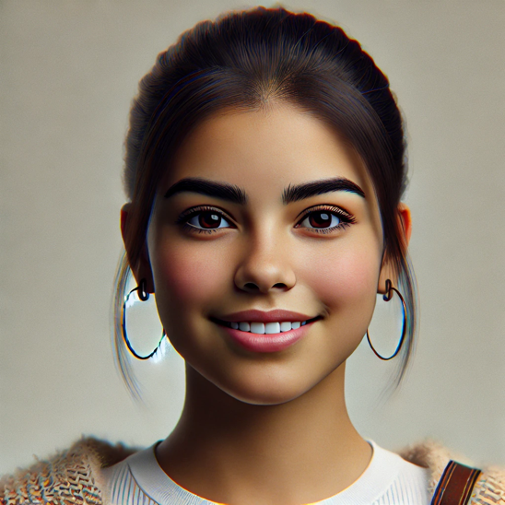
Images 1&2: AI-generated representative images of Sofia Ramirez created by Dall-E

Sofia Ramirez is a 21-year-old tech-savvy and socially conscious university student in Madrid, passionate about digital modern arts. She embodies RBO’s target audience, which is predominantly female individuals, 75.93%, and students, 67.59% (Appendix I.1.2&I.1.4).
Sofia actively uses streaming services and follows cultural organisations on TikTok and Instagram, valuing brands reflecting inclusivity and diversity. Her engagement aligns with Social Identity Theory, where RBO leverages shared cultural symbols to strengthen their connection. (Tajfel & Turner, 1979).
While budget constraints and limited exposure to authentic modern art forms challenge her, affordable streaming options meet her desires. Enthusiastic about her experience, Sofia shares it on social media, inspiring her peers and creating a cycle of social proof effect for RBO.

- Secondary Target Market: Lower-Income Household

The secondary target audience includes lower-income households aged 18-25, who are price-sensitive due to limited financial resources. This group seeks affordable, high-quality experiences that balance value and accessibility (GWI, RBO Audience: Lower Income Groups, 2024). They are drawn to transparent pricing, promotions, and flexible payment options which align with their need for affordability (Aghazadeh & Khoshnevis, 2024). RBO can engage this audience through low-cost streaming and interactive content, broadening its reach.

Persona 2: Lower-Income Household Audience - Daniel Turner (see Appendix D)


Images 3&4: AI-generated representative images of Daniel Turner created by Dall-E

Daniel Turner, a 24-year-old Dutch graduate who loves exploring London’s cultural scene-things that are “value-for-money” experiences, representing the potential target market. (Appendix I.1.1&I.1.3&I.1.4).
Daniel values transparent pricing and inclusivity but feels excluded from traditional cultural institutions due to financial barriers. Furthermore, he perceived art institutions cater exclusively to elite audiences with grand venues, high ticket prices, and dress codes, making traditional them inaccessible.
Motivated by accessible and affordable arts, he dedicates significant time to seek cultural activities that align with his values. By offering flexibility, such as discounted pay-per-view options, RBO can foster stronger connections.

Part C: Decision-Making Process of Each Target

RBO must tailor strategies to engage with its two distinct target segments whose decision-making behaviours are shaped by their unique preferences and behaviours.

- Primary Target Segment: Decision-Making Process
The Global Majority Audience’s decision-making process revolves around digital discovery, social validation, and value-driven engagement.
- Awareness
Initial interest is driven by social proof generated through influencer campaigns, viral content, and targeted digital advertisements on social media platforms like Instagram and TikTok. Engaging visuals, such as modern ballet clips or behind-the-scenes, resonates with their desire for inclusivity and authentic storytelling. Social Influence Theory emphasizes the impact of peer and influencer endorsements on shaping their decision by social validation, reinforced by interview insights (Kelman, 1958). Supported by Ajzen’s (1991) Theory of Planned Behaviour, highlights the importance of positive attitudes, social norms, and perceived control in shaping engagement with RBO.
- Consideration
Audience evaluates RBO’s offerings via websites, social media, and reviews. Promotions like student discounts or trial memberships that enhance perceived value. According to Prospect Theory, they evaluate potential gains and losses, embracing affordable, low-risk options. (Kahneman & Tversky, 1979).
- Engagement
They will likely subscribe to digital memberships or purchase tickets, motivated by limited-time discounts or influencer endorsements.

- Post-Purchase Stage
They actively share experiences on social media by creating user-generated content reinforcing their identity within a social group to create a sense of belonging aligning with Social Identity Theory (Tajfel & Turner, 1979).

- Secondary Target Segment: Decision-Making Process
Low-income Households’ decision-making focuses on affordability, accessibility, and value-driven experiences.
- Awareness
Budget-friendly ads, financial influencer partnerships, and promotions like pay-per-view options drive interest. Targeted messaging highlighting affordability and flexibility resonates strongly with them (Chaffey & Ellis-Chadwick, 2019). Value-Based Segmentation Theory emphasizes tailoring marketing efforts for perceived value, resonating with their need for cost-effective, high-value experiences (Kotler & Keller, 2016).
- Consideration
Rooted in Prospect Theory, they carefully weigh costs and perceived risks of engaging with RBO, comparing the available options (Kahneman & Tversky, 1979). Transparent pricing and trial offers help to reduce uncertainty and build trust.
- Engagement
Influenced by the Price Sensitivity Theory, they favour flexible, low-commitment options, without overstepping their financial boundaries (Monroe, 1990). They evaluate the quality of RBO’s offerings guided by Consumer Perceived Value (Zeithaml, 1988). Positive testimonials provide social proof, further encouraging commitment. Clear cost-value communication and guarantees can boost confidence in RBO’s offering.

- Post-purchase
They tend to share their experiences in value-sensitive communities or forums, aligning with Social Identity Theory by reinforcing their identity as resourceful consumers who value inclusive experiences (Tajfel & Turner, 1979).

By addressing these differentiated decision-making processes, RBO can successfully balance premium exclusivity with accessible and inclusive digital content for younger, budget-conscious audiences, fostering a sustainable and diverse customer base.

Section 4. Digital Marketing Communications

Part A: Campaign Objective and Message

The primary target segment for the campaign is the younger generation (18-25 years old), who perceive ballet and opera as classical, high-cost cultural experiences primarily for older generations. According to the interview and survey, this perception is mainly caused by key barriers, including high-price, unfamiliarity and negative perceptions of class and culture.
The campaign emphasises the message, “Experience the magic, anywhere,” a Call to Action (CTA) that contains the main point of RBO’s easy accessibility, both at the Royal Opera House and at home through streaming services.
Building customer loyalty is essential for cultural institutions; high-quality services and accessible pricing are crucial factors that contribute to long-term customer engagement and satisfaction (Meler, M., 2006). We will create an appealing brand perception to attract young audiences and build a long-term connection with customers who have modern and digital lifestyles. (Scheff Bernstein, 2007)
Our campaign objectives are divided into two parts: perception and practicality. The first goal is to change the perception of the Royal Ballet and Opera (RBO) among younger audiences, helping them perceive RBO as an inclusive space where people of all generations can enjoy cultural performances in a relaxed, engaging atmosphere. By prioritizing RBO's high-quality performances and strengths, they can position themselves among their competitors and eventually shift the perceptions of younger generations. (Appendix N)
Secondly, we suggest statistical expectations as below:
According to the KCL x RBO performance overview data, RBO has not recorded a significant increase in performance rate after rebranding (SINE, KCL x RBO performance overview, 2024). Therefore, more precise target segments and high-quality content must be required. For example, RBO recorded a relatively high-performance rate on TikTok, with an engagement rate of 25.24% and a strong video view rate of 23.51%. Based on our survey, as younger generations value communication on social media, particularly through short-form platforms such as TikTok and Instagram, we plan to create short content videos targeting them and aim for a realistic goal of approximately a 30% engagement rate and a 28% video view rate.
According to the geo-split of streaming audience data, we can observe that RBO’s main audience is focused on the UK, followed by the US and most European countries. However, they have recorded relatively low engagement rates from audiences outside Western countries, such as Asia and Africa. (SINE, Geo-split of streaming audience, 2024)
To achieve a better streaming service engagement rate, we suggest the following goals: increasing the subscription rates by 12% in high-performing markets, such as the UK and the US, and by approximately 8% in lower-performing countries, especially in Asia. The overall aim is to achieve 19,000 total subscriptions by August 2025 and increase international subscriptions by 20%.
Based on the interviewees' responses, young generations perceive RBO as a Western/European dominant art institution, emphasizing the importance of including cultural diversity and inclusivity. Therefore, redefining their value proposition, which was classic, elitist, and West-dominant culture, is the main challenge. We aim to make RBO a more accessible and welcoming place for younger audiences by building new, diverse, and inclusive values. This new approach will enhance engagement from younger generations.

Part B: Creative Campaign Execution and Media Channels

To begin with, we would like to utilise IMC (Integrated Multi-Channel Strategy) for our campaign to not only deliver consistent messages to the audience, but also to achieve a higher conversion rate, improve brand awareness, and build longer-lasting customer loyalty among younger audiences (Porcu, del Barrio-García & Kitchen, 2012). Based on RBO's elegant, classic, and artistic brand image, we will emphasize its key values through various image and video content. This can preserve the brand's unique identity and extend its presence across digital platforms.
We have selected three primary media channels: streaming services, social media, and offline media.

- Streaming Services

First, streaming services such as YouTube, Netflix, and Amazon Prime were chosen to deliver high-quality, visually captivating video content. By showcasing these videos (Appendix J), we can give impression on viewers and encourage them to convert into subscribers to RBO's streaming services. It is particularly suitable for individuals who are already interested in cultural experiences, such as ballet and opera, as well as for those who are not yet aware of RBO's streaming platform (Lobato, 2019).

- Social Media

Social Media Channel images (Appendix K) show content created for RBO's Instagram campaign, designed to engage audiences with visually appealing and many kinds of posts.
Secondly, we plan to leverage social media platforms such as TikTok and Instagram to engage with younger audiences aged 18-25, representing our primary target consumers. Insights from our interviews and surveys prove that younger audiences feel RBO needs stronger communication on social media. Additionally, some interviewees mentioned that their curiosity about new interests often begins with social media exposure.
Following this, we will create short, engaging videos on platforms including TikTok and Instagram, which are accessible and appealing to younger audiences (Appendix C). Through this content, we showcase that RBO is not only a place for experiencing world-class ballet and opera performances but also features various facilities such as rooftop bars, restaurants, and cafes.
This change can motivate younger generations to think RBO as a youthful and dynamic cultural place.

- Offline media

Lastly, we will focus on offline media including buses, underground stations, and cinemas in London (Appendix B and Appendix L). Buses and underground stations are iconic London landmarks that offer high visibility to both local residents and international visitors. Given that RBO embodies London’s tradition and cultural identity, placing advertisements in these high-traffic areas can effectively attract individuals who are eager to explore more cultural experiences in London. (Appendix M)

- KPI table

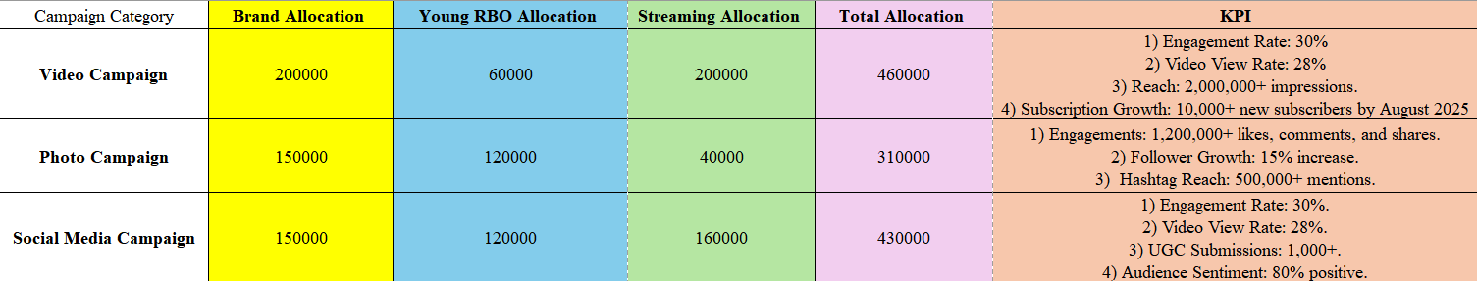
Table 4-a: The table includes the allocated budget for three campaigns: Video, Photo, and Social Media, along with performance goals such as engagement rates, video view rates, reach, and subscription growth figures.

Based on the allocated budget, we plan to divide it into three parts and design each campaign to achieve specific KPIs, as outlined in the table. As mentioned in Part A, the overall goals are to achieve a total engagement rate of 30%, and a total of 19,000 streaming subscribers by August 2025. Also, we plan to reduce the churn rate by 17% and increase international subscriptions by 20%.

These three chosen channels each have their own distinct strengths and characteristics. Online platforms are necessary to make higher digital engagement and changing perceptions among younger audiences, while offline advertising can emphasise RBO's presence across London’s main locations. By complementing one another, this IMC strategy can maximise interaction and develop new brand awareness among global and broader audiences.

Reference List

Aghazadeh, H., & Khoshnevis, M. (2024). Digital Marketing Technologies. Springer Verlag, Singapore.
Ajzen, I. (1991). The Theory of Planned Behavior. Organizational Behavior and Human Decision Processes, 50(2), pp.179–211. doi:https://doi.org/10.1016/0749-5978(91)90020-T.
Artistic Strategy Acknowledgement of Country. (n.d.). https://www.sydneyoperahouse.com/sites/default/files/collaborodam_assets/artistic-strategy-2022-online.pdf
Arts Council England. (2011). Arts audience insight 2011. [online] Available at: https://www.artscouncil.org.uk/sites/default/files/download-file/arts_audience_insight_2011.pdf
Arts Review. (2018, March 3). Sydney Opera House reveals its first-ever Mardi Gras float. Australian Arts Review. https://artsreview.com.au/sydney-opera-house-reveals-its-first-ever-mardi-gras-float/
Brand use requests. (2024). Sydney Opera House. https://www.sydneyoperahouse.com/brand-use-requests
Bruner, I. G. C. (2017). Marketing Scales Handbook: Multi-item measures for consumer insight research, volume 9 (pp. 118). GCBII Productions, LLC. https://ebookcentral.proquest.com/lib/kcl/reader.action?docID=4843087&ppg=144
Byrnes, W. J. (2009). Management and the Arts. Focal Press.
Centre, U. W. H. (n.d.). Sydney Opera House. UNESCO World Heritage Centre. https://whc.unesco.org/en/list/166/gallery/
Chaffey, D., & Ellis-Chadwick, F. (2019). Digital marketing: Strategy, implementation and practice (7th ed.). Pearson Education Limited.
Chi, C. G., & Gursoy, D. (2009). Employee satisfaction, customer satisfaction, and financial performance: An empirical examination. International Journal of Hospitality Management, 28(2), 245-253.
Colbert, F. (2003). Entrepreneurship and Leadership in Marketing the Arts. Journal of Arts Management, Law, and Society.
Cultural Branding: Harnessing Cultural Conflict to Create Icons. Harvard Business Review. (2016).
Culture Track. (2021). Culture and community in a time of transformation. Retrieved from https://www.culturetrack.com
Dearnley, C. (2005). A reflection on the use of semi-structured interviews. Nurse researcher, 13(1).
Deloitte (2024). The Deloitte Global 2024 Gen Z and Millennial Survey. [online]Deloitte. Available at: https://www.deloitte.com/global/en/issues/work/content/genz-millennialsurvey.html.
Deloitte. (2020). Digital Media Trends: Consumption Habits Survey
DR5. (n.d.). Dressing Room 5 - Theatre Marketing Agency | UK Tours and West End. Retrieved from https://www.dr5.co.uk/
English National Opera. (n.d.). About. Retrieved November 17, 2024, from https://www.eno.org/about/
English National Opera. (n.d.). Annual reviews and funding sources. Retrieved November 17, 2024, from https://www.eno.org/about/annual-reports-our-funding/
English National Opera. (n.d.). Attending opera for the first time?. Retrieved November 17, 2024, from https://www.eno.org/your-visit/attending-opera-for-the-first-time/
English National Opera. (n.d.). Donate now. Retrieved November 17, 2024, from https://www.eno.org/support-us/donate-now/
English National Opera. (n.d.). English National Opera. Retrieved November 17, 2024, from https://www.eno.org/
English National Opera. (n.d.). ENO Brand Guidelines: Logo. Retrieved November 17, 2024, from https://www.eno.org/about/eno-brand-guidelines/
English National Opera. (n.d.). ENO Engage. Retrieved November 17, 2024, from https://www.eno.org/discover-opera/eno-engage/
English National Opera. (n.d.). ENO Friends. Retrieved November 17, 2024, from https://www.eno.org/support-us/become-a-member/eno-friends/
English National Opera. (n.d.). ENO TV. Retrieved November 17, 2024, from https://www.eno.org/eno-tv/
English National Opera. (n.d.). ENO’s Vision and Mission. Retrieved November 17, 2024, from https://www.eno.org/about/enos-mission/
English National Opera. (n.d.). How to book your opera tickets. Retrieved November 17, 2024, from https://www.eno.org/your-visit/how-to-book/
English National Opera. (n.d.). Opera Circle Supporters. Retrieved November 17, 2024, from https://www.eno.org/support-us/become-a-member/opera-circle-supporters/
English National Opera. (n.d.). Opera Squad. Retrieved November 17, 2024, from https://www.eno.org/discover-opera/eno-engage/schools/secondary-schools/opera-squad/
English National Opera. (n.d.). Opera Tickets: ENO’s Ways to Save. Retrieved November 17, 2024, from https://www.eno.org/your-visit/ways-to-save-offers/
English National Opera. (n.d.). Operas. Retrieved November 17, 2024, from https://www.eno.org/discover-opera/operas/
English National Opera. (n.d.). Professional development. Retrieved November 17, 2024, from https://www.eno.org/about/professional-development/
English National Opera. (n.d.). Retrieved from https://www.eno.org
Etikan, I., Musa, S. A., & Alkassim, R. S. (2016). Comparison of convenience sampling and purposive sampling. American Journal of Theoretical and Applied Statistics, 5(1), 1-4.
Goh, K. Y., Heng, C. S., & Lin, Z. (2013). Social Media Brand Community and Consumer Behavior: Quantifying the Relative Impact of User- and Marketer-Generated Content. Marketing Science, 32(5), 612-626.
Guachalla, A. (2017) ‘Social Inclusion and audience development at the Royal Opera House: A Tourist Perspective’, International Journal of Culture, Tourism and Hospitality Research, 11(3), pp. 436–449. doi:10.1108/ijcthr-07-2016-0071.
GWI (2024). RBO global minority audience,*global majority+ theatre + entertainment interest*
GWI (2024). RBO global minority audience,*lower income groups + theatre + entertainment interest*
Hello. (n.d.). Retrieved November 4, 2024, from https://www.besydney.com.au/media/h1kp5lkp/soh-third-party-brand-guidelines.pdf
Hill, E., O’Sullivan, C., & O’Sullivan, T. (2003). Creative Arts Marketing. Routledge.
House, S. O. (2021). Sydney Opera House – Stream. Google.com. https://play.google.com/store/apps/details/Sydney_Opera_House_Stream?hl=en&id=com.sydneyoperahouse
How Sydney Opera House personally and directly invited visitors to #ComeOnIn. (2017, September 18). Marketing Mag. https://www.marketingmag.com.au/social-digital/how-sydney-opera-house-personally-and-directly-invited-visitors-to-comeonin/
Hunt, E. (2013, December 12). ‘ENO Screen’ follows the digital trend. Arts Professional. https://www.artsprofessional.co.uk/news/eno-screen-follows-digital-trend
Influencers are the new public intellectuals: All About Women 2024 - All About Women 2024 Festival Pass - Stream - Sydney Opera House. (2024). Stream - Sydney Opera House. https://stream.sydneyoperahouse.com/packages/all-about-women-2024-festival-pass/videos/influencers-are-the-new-public-intellectuals-all-about-women-2024-1
Kahneman, D., & Tversky, A. (1979). Prospect theory: An analysis of decision under risk. Econometrica, 47(2), 263–291.https://doi.org/10.2307/1914185
Kapferer, J. N. (2012). The New Strategic Brand Management: Advanced Insights and Strategic Thinking.
Kelman, H. C. (1958). Compliance, identification, and internalization three processes of attitude change. Journal of Conflict Resolution, 2(1), 51-60.
Kim, W. C., & Mauborgne, R. A. (2015). Chapter 2: Analytical tools and frameworks. In Blue ocean strategy, expanded edition: How to create uncontested market space and make the competition irrelevant (Rev. ed.). Harvard Business Review Press.
Kotler, P., & Keller, K. L. (2016). Marketing management (15th ed.). Pearson Education.
Kotler, P., & Scheff, J. (1997). Standing Room Only: Strategies for Marketing the Performing Arts. Harvard Business School Press.
Litman, R. (2022). For Gen Z, Brand Is What You Share, Not What You Sell — Part I | Ogilvy. [online] www.ogilvy.com. Available at: https://www.ogilvy.com/ideas/gen-z-brand-what-you-share-not-what-you-sell-part-i [Accessed 6 Nov. 2024].
Lobato, R. (2019). Netflix nations: The geography of digital distribution. New York, NY: NYU Press.
London Coliseum. (n.d.). London Coliseum shop. Retrieved November 17, 2024, from https://shop.londoncoliseum.org/
Maslow, A. H. (1943). A theory of human motivation. Psychological Review, 50(4), 370–396. https://doi.org/10.1037/h0054346
McKinsey & Company. (2021). The future of personalization—and how to get ready for it.
McLeod, S. (2024). Maslow’s Hierarchy of Needs. [online] Simply Psychology. Available at: https://www.simplypsychology.org/maslow.html.
Meler, M. (2006). Marketing u kulturi. Osijek: Ekonomski fakultet u Osijeku.
Metropolitan Opera. (2023). About the Met. Retrieved from https://www.metopera.org
Metropolitan Opera. (2023). Content marketing and audience engagement. Retrieved from https://www.metopera.org
Metropolitan Opera. (2023). Conversion and audience engagement. Retrieved from https://www.metopera.org
Metropolitan Opera. (2023). Influencer outreach and partnerships. Retrieved from https://www.metopera.org
Metropolitan Opera. (2023). Live in HD. Retrieved from https://www.metopera.org
Metropolitan Opera. (2023). Membership programs and community engagement. Retrieved from https://www.metopera.org
Metropolitan Opera. (2023). Revenue and funding overview. Retrieved from https://www.metopera.org
Metropolitan Opera. (2023). Tickets and membership options. Retrieved from https://www.metopera.org
Metropolitan Opera. (2023). Website and branding overview. Retrieved from https://www.metopera.org
Metropolitan Opera. (n.d.). Retrieved from https://www.metopera.org
Monroe, K. B. (1990). Pricing: Making profitable decisions (2nd ed.). McGraw-Hill.
National Endowment for the Arts. (2017). A decade of arts engagement: Findings from the Survey of Public Participation in the Arts, 2005–2015. Retrieved from https://www.arts.gov/impact/research/research-publications
National Endowment for the Arts. (2019). Funding and financial support for the arts. Retrieved from https://www.arts.gov/impact/research/research-publications
Neil Patel. (2023). Traffic analyzer: metopera.org. Retrieved from https://app.neilpatel.com/en/traffic_analyzer/overview?domain=metopera.org
Official Theatre. (n.d.). Changing Face of London Theatre Marketing - Musicals in the West End. Retrieved from https://www.officialtheatre.com/blog/changing-face-of-london-theatre-marketing/
Osterwalder, A., Pigneur, Y., Bernarda, G., & Smith, A. (2014). Value Proposition Design: How to Create Products and Services Customers Want
Peracchio, L. A., Bublitz, M. G., & Luna, D. (2014). Cultural diversity and marketing: The multicultural consumer. In V. Benet-Martínez & Y.-Y. Hong (Eds.), The Oxford handbook of multicultural identity. Oxford Library of Psychology. Oxford Academic.
Pew Research Center. (2018). Social Media Use in 2018: Demographics and Statistics
Porcu, L., del Barrio-García, S., & Kitchen, P. J. (2012). How Integrated Marketing Communications (IMC) works? A theoretical review and an analysis of its main drivers and effects. Academia Revista Latinoamericana de Administración, 49, 103-130. https://doi.org/10.1108/ARLA-04-2018-0091
Royal Ballet and opera (2024) Royal Ballet and Opera. Available at: https://www.rbo.org.uk/ (Accessed: 04 December 2024).
Royal Opera House (2024) Royal Opera House | Covent Garden. Available at: https://www.coventgarden.london/experience/theatres/royal-opera-house/ (Accessed: 04 December 2024).
Scheff Bernstein, J. (2007). Arts marketing insights: The dynamics of building and retaining performing arts audiences. San Francisco, CA: John Wiley & Sons.
Schivinski, B., & Dabrowski, D. (2016). The effect of social media communication on consumer perceptions of brands. Journal of Marketing Communications, 22(2), 189-214.
SINE. (2024). Geo-split of streaming audience.
SINE. (2024). KCL x RBO performance overview.
SimilarWeb. (2023). Website performance: metopera.org. Retrieved from https://pro.similarweb.com/#/digitalsuite/websiteanalysis/overview/website-performance/*/999/1m?webSource=Total&key=metopera.org
SimilarWeb. (2023). Website performance: metopera.org. Retrieved from https://pro.similarweb.com/#/digitalsuite/websiteanalysis/overview/website-performance/*/999/1m?webSource=Total&key=metopera.org
Similarweb. (n.d.). Website performance: eno.org. Retrieved November 17, 2024, from https://pro.similarweb.com/#/digitalsuite/websiteanalysis/overview/website-performance/*/999/1m?webSource=Total&key=eno.org
Similarweb. (n.d.). Website performance: rbo.org.uk. Retrieved November 17, 2024, from https://pro.similarweb.com/#/digitalsuite/websiteanalysis/overview/website-performance/*/999/1m?webSource=Total&key=rbo.org.uk
Simonin, B. L., & Ruth, J. A. (1998). Is a company known by the company it keeps? Assessing the spillover effects of brand alliances on consumer brand attitudes. Journal of Marketing Research, 35(1), 30-42.
Smith, J. (2019). Audience engagement in the performing arts: Demographic analysis and trends. New York, NY: Routledge.
Statista. (2022). Digital media consumption among millennials and Gen Z. Retrieved from https://www.statista.com
Statista. (2022). Digital media consumption among millennials and Gen Z. Retrieved from https://www.statista.com
Statista. (n.d.). Theatre and the West End in the United Kingdom (UK) - Statistics & Facts. Retrieved from https://www.statista.com/topics/3689/theatre-and-the-west-end-in-the-united-kingdom-uk/#topicOverview
Strategies and Action Plans. (n.d.). Sydney Opera House. https://www.sydneyoperahouse.com/about-us/how-we-work/strategies-and-action-plans
Stream. (2023). Sydney Opera House. https://www.sydneyoperahouse.com/stream
Sundar, S. S., & Kalyanaraman, S. (2004). Arousal, memory, and impression-formation effects of animation speed in web advertising. Journal of Advertising, 33(1), 7-17.
Support. (2024). Sydney Opera House. https://www.sydneyoperahouse.com/support
Sydney Opera House / Jørn Utzon. (2022, January 20). ArchEyes. https://archeyes.com/sydney-opera-house-jorn-utzon/
Sydney Opera House Strategy. (2024). Sydney Opera House. https://dc8smvz8l4jlg.cloudfront.net/about-us/how-we-work/strategies-and-action-plans/sydney-opera-house-strategy
Sydney Opera House. (2016). Tour the Sydney Opera House in 360° | Featuring soprano Nicole Car and the Sydney Symphony Orchestra. In YouTube. https://www.youtube.com/watch?v=_hunddVoMjo
Sydney Opera House. (2019). TripAdvisor. https://www.tripadvisor.com/Attraction_Review-g255060-d257278-Reviews-Sydney_Opera_House-Sydney_New_South_Wales.html
Sydney Opera House. (2024, July 30). Interbrand. https://interbrand.com/work/sydney-opera-house/
Sydney Opera House. (n.d.). Behind a Great Project. https://behindagreatproject.com/structure/sydney-opera-house/
Sydney Opera House. (n.d.). Retrieved from https://www.sydneyoperahouse.com
Sydney Opera House. (n.d.). YouTube. Retrieved November 3, 2024, from https://www.youtube.com/channel/UCvzqRBw-s63GzEaI4q4Y8dg
Sydney Opera House: The story of an icon in photos. (2023, October 19). BBC News. https://www.bbc.co.uk/news/world-australia-67153713
Tajfel, H., & Turner, J. (1979). An integrative theory of inter-group conflict. In J. A. Williams & S. Worchel (Eds.), The social psychology of inter-group relations (pp. 33-47). Belmont, CA: Wadsworth.
Taylor, V. A., & Bearden, W. O. (2002). The effects of price on brand extension evaluations: The moderating role of extension similarity. Journal of the Academy of Marketing Science, 30, 131-140.
The Sydney Opera House: a world leading sustainability performance | Green Building Council of Australia. (n.d.). New.gbca.org.au. https://new.gbca.org.au/case-studies/building/the-sydney-opera-house-a-world-leading-sustainability-performance/
Think with Google. (2019). Digital Media Trends: How Media Companies Are Adapting to Gen Z
Think with Google. (2020). Marketing to Gen Z: What the Most Successful Brands Get Right
Think with Google. (n.d.). How London Theatre Direct drove sales with automation. from https://www.thinkwithgoogle.com/intl/en-emea/marketing-strategies/automation/london-theatre-search-automation/
Tilden, I. (2024) Royal Ballet and opera announces ambitious 2024-25 season – and name change, The Guardian. Available at: https://www.theguardian.com/culture/2024/apr/30/royal-ballet-and-opera-announces-ambitious-new-season-and-name-change-2024-25 (Accessed: 04 December 2024).
Tourism Investment Monitor 2019-20 | Tourism Research Australia. (n.d.). Www.tra.gov.au. https://www.tra.gov.au/en/economic-analysis/tourism-investment-monitor/tourism-investment-monitor-2019-20
Tripadvisor (n.d.). Reviews: English National Opera. Retrieved November 17, 2024, from https://www.tripadvisor.co.uk/Attraction_Review-g186338-d15554611-Reviews-English_National_Opera-London_England.html
Trustpilot. (2023). Royal Opera House reviews. Retrieved from https://uk.trustpilot.com/review/roh.org.uk
Tutuncu, O. (2017). Investigating the accessibility factors affecting hotel satisfaction of people with physical disabilities. International Journal of Hospitality Management, 65, 29-36.
Tybout, A. M., & Calkins, T. (2005). Kellogg on Branding: The Marketing Faculty of the Kellogg School of Management
Ubersuggest. (2024). Project Title: eno.org. Retrieved December 04, 2024, from https://app.neilpatel.com/en/dashboard
Volpe, J. (2006). The toughest show on earth: My rise and reign at the Metropolitan Opera. New York, NY: Knopf.
Web Accessibility Initiative. (2023). Web Accessibility. Retrieved from https://www.webaccessibility.com
Web Accessibility. (n.d.). Get Your Free Web Accessibility Health Score: eno.org. Retrieved November 17, 2024, from https://www.webaccessibility.com/thank-you-get-your-free-web-accessibility-health-score/?submissionGuid=2724991e-0e5f-48fd-befa-9738c5c135bf
West End Theatre. (2022). Industry News: West End box-office data for 2022 released. Retrieved from https://www.westendtheatre.com/155836/news/industry-news-west-end-box-office-data-for-2022-released/
West End Theatre. (n.d.). Facebook page. Facebook. Retrieved from https://www.facebook.com/west-end-theatre/
West End Theatre. (n.d.). Instagram page. Instagram. Retrieved from https://www.instagram.com/westendtheatrecom/
West End Theatre. (n.d.). Official website. West End Theatre. Retrieved from https://www.westendtheatre.com/
West End Theatre. (n.d.). Twitter page. Twitter. Retrieved from https://twitter.com/westendtheatre
West End Theatre. (n.d.). YouTube channel. YouTube. Retrieved from https://www.youtube.com/user/WestEndTheatre
Yi, Y., & Jeon, H. (2003). Effects of loyalty programs on value perception, program loyalty, and brand loyalty. Journal of the Academy of Marketing Science, 31(3), 229-240.
Zeithaml, V. A. (1988). Consumer perceptions of price, quality, and value: A means-end model and synthesis of evidence. Journal of Marketing, 52(3), 2–22. https://doi.org/10.1177/002224298805200302

Appendices

Appendix A: Competitor Benchmarking Table
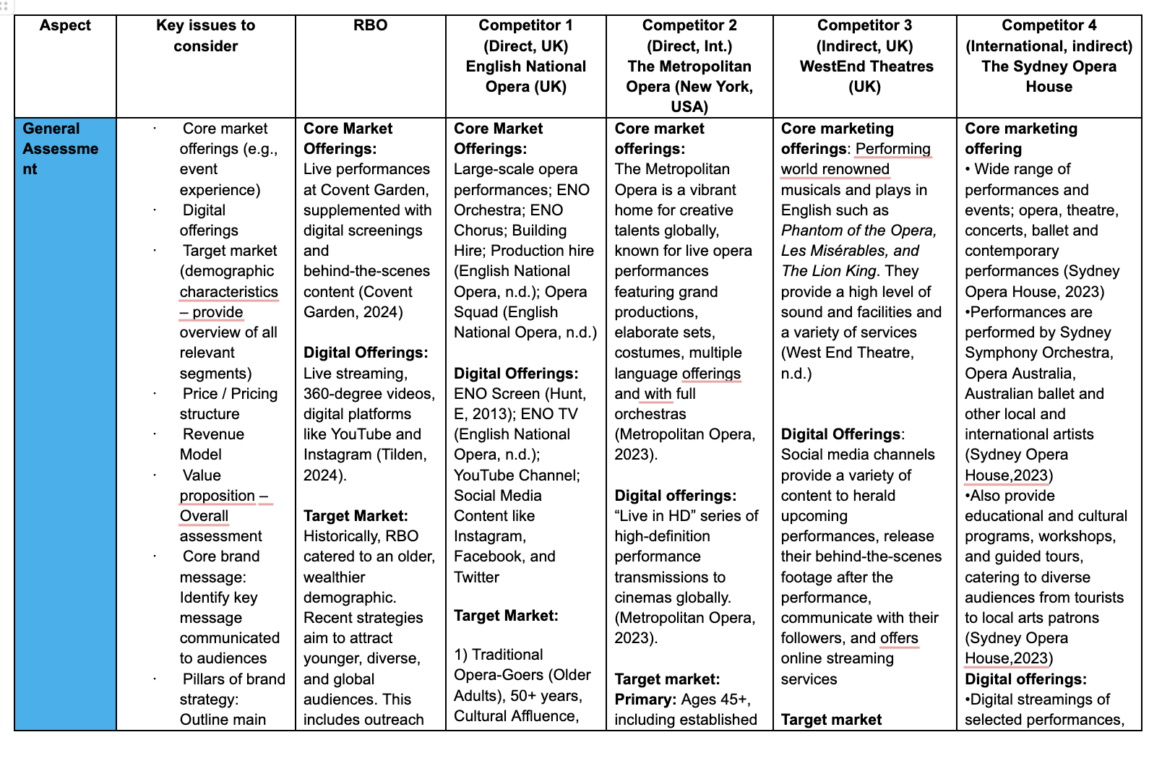
Link to full benchmarking table here

Appendix B: Mock-ups of offline media

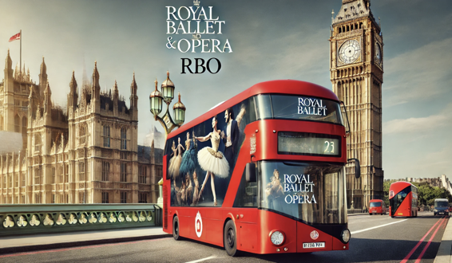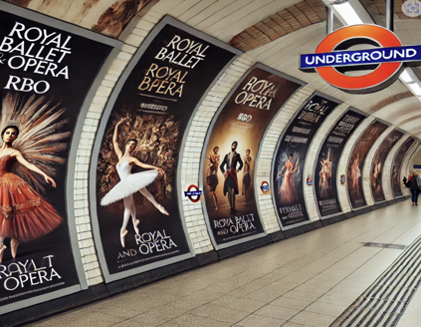
Images 1&2: AI-generated promotional materials for the Royal Ballet & Opera (RBO), created using ChatGPT.

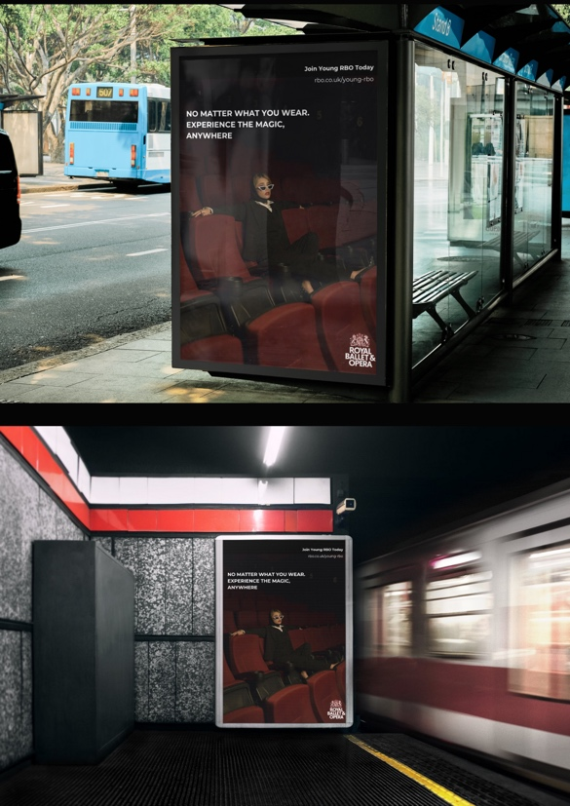
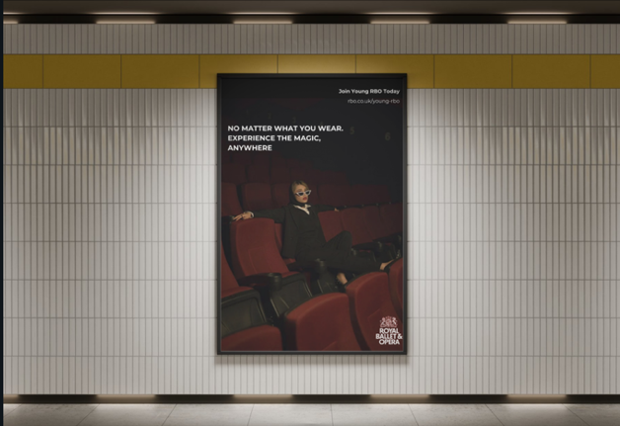

Appendix C: Storyboard of a TikTok Influencer
‘Spend a Day With Me’
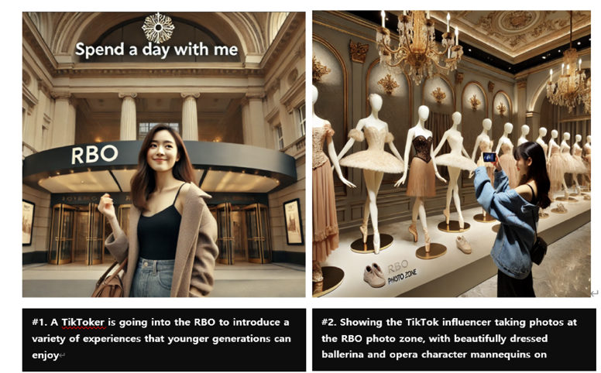
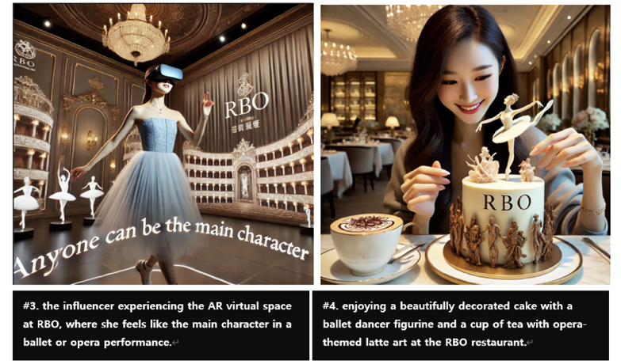
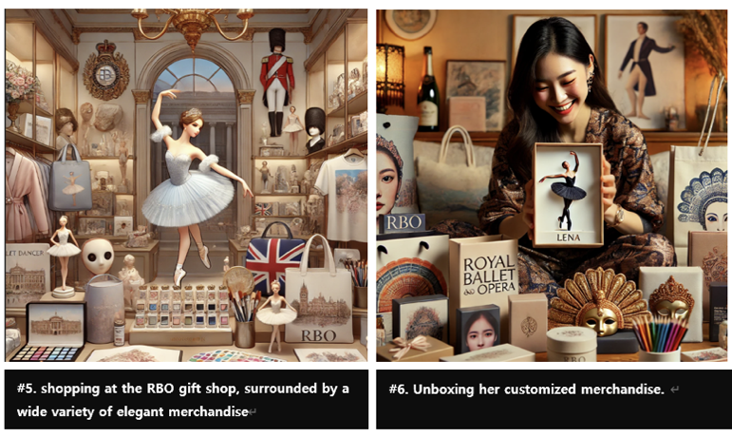
Images 1-6: AI-generated storyboard for the Royal Ballet & Opera (RBO), created using ChatGPT.

Appendix D: Consumer Persona Profiles
Persona 1: Primary Target Market - Hispanic Global Majority Audience
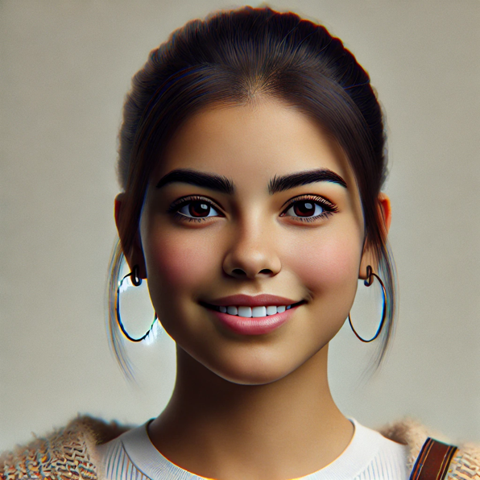
Images 1&2: AI-generated representative images of Sofia Ramirez created by Dall-E
Name: Sofia Ramirez
Description: A 21-year-old university student in Madrid, Spain, Sofia is passionate about digital culture and the arts. She seeks authentic brand interactions and loves sharing her experiences on social media, where she shares her unique take on art and culture with her growing follower base. Her values of inclusivity, diversity, and cultural connection align strongly with the mission of the Young RBO programme.
Demographic Information
- Age: 21
- Gender: Female
- Origin: Hispanic
- Location: Madrid, Spain
- Educational Level: Undergraduate in Digital Media and Communications
- Occupation: Part-time graphic designer at a startup
- Income Level: Moderate
Psychographic Profile
- Interests: Digital arts, ballet, cultural events, social media, streaming services.
- Values and Beliefs: Values authenticity, diversity, and cultural representation.
- Personality Traits: Enthusiastic, creative, open-minded, friendly.
- Lifestyle: Culturally engaged, socially connected, eco-conscious, budget friendly.
Digital Consumer Behaviour:
- Social Identity Theory: Sofia’s digital behaviour aligns with Social Identity Theory, where RBO leverages shared cultural symbols to express her identity, enhancing her engagement with brands that reflect her values. (Tajfel & Turner, 1979).
Behavioural Characteristics
- Buying Behaviour: Prefers digital subscriptions with flexible access, whenever and wherever is convenient for her; seeks exclusive and interactive content.
- Product/Service Usage: Uses streaming platforms, follows arts organizations on social media.
- Preferred Communication Channel: Instagram, TikTok, YouTube.
Digital Consumer Behaviour:
- Social Influence Theory: Influenced by peers, Sofia seeks digital content validated by influencers and friends. Social Influence Theory (Kelman, 1958) explains her reliance on social proof, such as shared reviews, which shape her decision to subscribe to RBO’s content.

Pain Points & Challenges
- Accessing culturally rich content within a student budget.
- Desire for content that feels relevant and authentic.
- Lack of exposure to modern interpretations of traditional art forms.
- Difficulty connecting with like-minded individuals in the arts.
Motivation & Goals
- Key Motivation: Connecting with cultural experiences that reflect her heritage and interests.
- Goals: Engage with meaningful arts experiences and share them with her online community.
- Emotional Triggers: Exclusive access, personalized content, community engagement.
Content Preferences
- Content Format: Short videos, interactive stories (e.g. Q&A), behind-the-scenes.
- Topics of Interest: Cultural storytelling, artist interviews, modern interpretations of classic arts, influencer experiences.
Marketing & Messaging Guidelines
- Tone of Voice: Friendly, inclusive, inspiring.
- Value Proposition: "Experience the arts in a way that's authentic, accessible, and tailored for you."
- Suggested Keywords and Phrases: “Authentic cultural experiences,” “exclusive access,” “join the new wave of arts enthusiasts”

Customer Journey & Decision-Making Process
- Awareness Stage
  - Discovers RBO through a viral TikTok video featuring a modern ballet performance.
  - Sofia’s journey begins with social proof shared by an influencer. This influences her awareness of RBO, establishing an initial appeal among a digitally native audience. (Social Influence)
- Consideration Stage
  - Explores affordable digital packages with student discounts and exclusive content.
  - Sofia’s decision to explore RBO packages aligns with the Theory of Planned Behaviour (Ajzen, 1991), as her attitudes, subjective norms, and perceived control lead her to investigate further. (Theory of Planned Behaviour)
- Decision Stage
  - Subscribes to a monthly plan offering live-streamed performances and interactive features.
  - Sofia is motivated to subscribe by the perceived value of RBO’s exclusive and relevant content, which meets her need for quality at an affordable price. (Consumer Perceived Value)
- Post-purchase Behaviour
  - Shares her experiences on social media, encouraging her friends to join.
  - After experiencing RBO’s performances, Sofia shares her insights on Instagram, reinforcing her identity within her community as an advocate for accessible cultural engagement. This creates a loop of social proof, as friends and followers are influenced to engage with RBO. (Social Identity and Impression Management)
Example Scenario
Sofia watches a captivating ballet clip on Instagram Reels. Enchanted by the reel, Sofia clicks through to the RBO profile and learns about the Young RBO streaming subscription. She’s thrilled to see affordable, student-friendly packages that would allow her to access these performances from anywhere. Without hesitation, she subscribes, eager to experience the magic of live ballet from the comfort of her own home.
Later that evening, Sofia tunes into a live-streamed performance. Captivated by the elegant dancers and modern staging, she begins recording snippets on her phone. She shares her favourite moments on her Instagram Story, tagging RBO and adding a caption about how accessible and magical the experience feels. Her followers quickly engage, intrigued by her enthusiasm and curious about the RBO streaming channel.
The next day, Sofia receives messages from friends, asking about the subscription and commenting on how relatable and inclusive the clip felt. Some of them even mention their own memories of similar jewellery boxes, reinforcing the personal connection RBO aimed to create. Sofia feels proud to be part of a community that values accessible, transformative arts experiences and looks forward to sharing more magical moments with her audience

Persona 2: Secondary Target Market - Low-Income Household

Images 3&4: AI-generated representative images of Daniel Turner created by Dall-E
Name: Daniel Turner
Description: Daniel is a 24-year-old recent graduate in Urban Planning from London, UK, working as a project assistant at a local council office. He’s budget-conscious but enthusiastic about affordable ways to engage with the arts and cultural experiences.
Daniel often feels overwhelmed by the perceived exclusivity of cultural experiences in London. Growing up in a working-class household, he’s used to choosing entertainment options based on affordability and practicality, rather than high-cost events. The traditional image of the arts—grand venues, high ticket prices, and dress codes—has made cultural experiences feel out of reach for someone on an entry-level income like his. This exclusivity often gives him the impression that he doesn’t fully belong in such settings, reinforcing his tendency to seek more accessible and inclusive options.

Demographic Information
- Age: 24
- Gender: Male
- Origin: Dutch
- Location: London, UK
- Educational Level: Bachelor’s degree in Urban Planning
- Occupation: Project Assistant at a local council office
- Income Level: Low, entry-level salary
Psychographic Profile
- Interest: Community development, affordable arts, work events
- Values and Beliefs: Practicality, high-quality, accessibility.
- Personality Traits: Friendly, down-to-earth, socially conscious, hard-working.
- Lifestyle: Lives on a budget, time-conscious, socially active, adventurer
Digital Consumer Behaviour:
- Theory of Planned Behavior: Daniel’s interest in community-based urban development and affordable experiences aligns with the Theory of Planned Behavior (Ajzen, 1991), where his intention to participate in affordable cultural activities is driven by his positive attitude toward them, social norms within his circle, and the perceived ease of attending through flexible pricing and access.
Behavioural Characteristics
- Buying Behaviour: Prioritises discounts, flexible pricing, and low commitment offers
- Product/Service Usage: Selective about spending, prefers budget-friendly entertainment options
- Preferred Communication Channel: Instagram, community newsletters, review websites, LinkedIn, Facebook, X
Digital Consumer Behaviour:
- Price Sensitivity Theory: Daniel’s decision-making is influenced by Price Sensitivity Theory (Monroe, 1990), where his low income heightens his sensitivity to price, especially in non-essential expenses. Thus, discounts and perceived high value are critical factors in his choices.
- Social Influence Theory: Daniel relies on social proof and shared experiences, especially when choosing to engage in new activities. Social Influence Theory (Kelman, 1958) suggests that he’s more likely to try RBO’s offerings if they come recommended by friends or are validated through community-based channels.
Pain Points & Challenges
- Limited cultural experience options due to budget, high living costs in London.
- Concerned about finding value in his spending choices.
- Perceived exclusivity of cultural experiences makes him feel alienated by cost or status barriers.
Motivation & Goals
- Key Motivation & Goal: Engage in accessible cultural events, explore London’s art scene within his budget.
- Emotional Triggers: Transparent pricing, discounts, and flexible, value-driven experiences
Content Preferences
- Content Format: Value-oriented guides, local event highlights
- Topics of Interest: Arts and culture in London, affordable activities, community-based urban development
Marketing & Messaging Guideline
- Tone of Voice: Approachable, value-focused, practical
- Value Proposition: “Experience London’s culture affordably and with flexibility.”
- Suggested Keywords and Phrases: “Budget-friendly arts access,” “explore culture on a budget,” “flexible plans for all budgets”
Customer Journey & Decision-Making Process
- Awareness Stage
  - Daniel notices a sponsored post on Instagram promoting RBO’s affordable digital packages. The perceived affordability aligns with his price sensitivity, and seeing the ad in a trusted channel reinforces the social proof. (Social Influence and Price Sensitivity)
- Consideration Stage
  - His motivation to find value-oriented cultural content leads him to review RBO’s flexible plans and free trial options. His positive attitude toward arts, paired with flexible pricing, increases his perceived control over the decision, strengthening his intent to subscribe. (Planned Behaviour)
- Decision Stage
  - Daniel decides to sign up for a low-cost entry plan, motivated by perceived value through transparent pricing and affordable, no-commitment flexibility. (Consumer Perceived Value)
- Post-purchase Behaviour
  - After experiencing a performance, Daniel shares his positive experience with friends, aligning with his identity as someone who values accessible, community-oriented experiences. This reinforces his advocacy for RBO as an affordable, quality option. (Social Identity)

Example Scenario
Daniel sees a discounted streaming option for RBO on Facebook. Drawn by the low-cost entry and flexibility, he subscribes, enjoys a live-streamed performance, and shares the affordable service with a friend who also appreciates budget-friendly cultural experiences.
Seeing that RBO offers budget-friendly options, flexible subscription models, and messaging that speaks to inclusion rather than elitism allows him to feel reassured and invited rather than intimidated.
Daniel appreciates RBO’s transition from an elite, exclusive institution to a cultural hub that is now accessible and inclusive for people across backgrounds and income levels. This shift aligns with his social consciousness, fostering a sense of community and welcoming those who may not have previously felt the arts were within reach.

Appendix E: Measures and Measurements Table
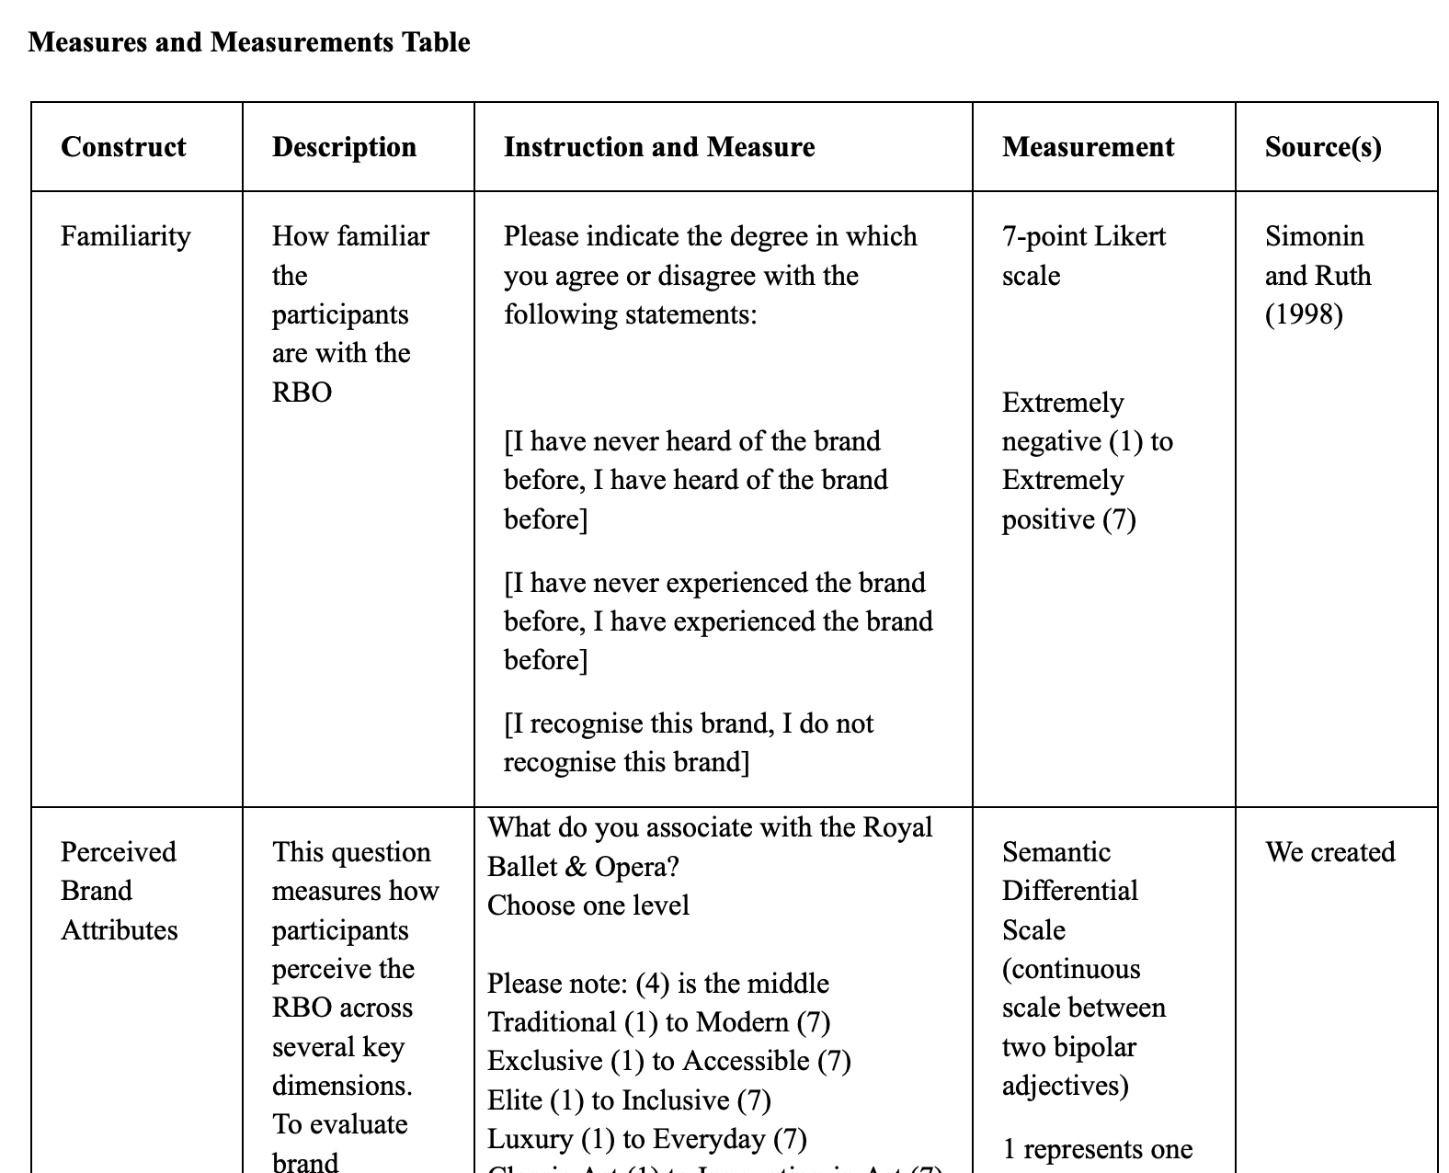
Link to Measure and Measurements table here

Appendix F: Questionnaire Preview

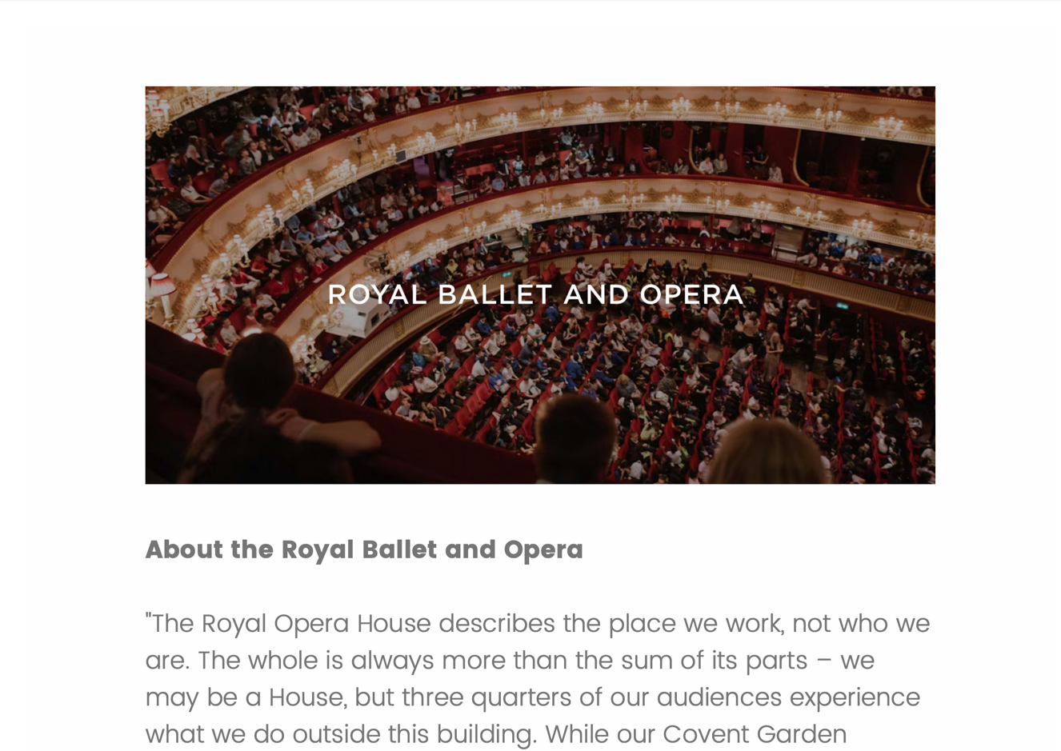
Link to questionnaire preview via Qualtrics

Appendix G: Interview Guide

(Consent forms including Information Sheet and/or listened to an explanation about the research has been provided to all interviewees and signed by them, available upon request)

To begin:
1) Thank them for talking to you and tell them how excited you are to be interviewing them.
2) Ask them if they have read through the informed consent form and agree to the terms.
3) Ask them if it is okay that you record the interview so that you do not miss anything.
4) Remember to turn on the recorder.
5) Let them know that they are welcome to stop at any time.

Section 1 – Preliminaries

1. Please tell us a bit about yourself: How old are you? What is your occupation?
2. Would you identify with any of the following social groups? (young, disabled or minority customer)

Section 2 – General Awareness and Familiarity
1. Have you heard of the Royal Ballet and Opera before?/ How familiar are you with the Royal Ballet and Opera?
a. Possible follow-up: Have you ever attended a performance by the Royal Ballet or Opera?
b. Follow-up: How did you first hear about them (e.g., social media, friends, school)? (Young)
c. Follow-up: What stood out to you about the experience?
d. Follow-up: Can you name any specific performances, productions, or artists associated with RBO?
e. How was your experience in terms of accessibility (e.g., venue, seating, audio descriptions, sign language, etc.)? (Disabled)
f. Did you feel welcome and included in the experience? (minority)
g. Follow-up: Would you consider going to another performance, and what would make you want to go?

Section 3 – Perceived Brand Associations
1. When you think of the Royal Ballet and Opera, what comes to mind?
a. Do you feel that it’s something that speaks to your culture, interests, or identity? Why or why not? (minority)
b. Follow-up: Is it something you think is more for older people or also for younger audiences like you? (Young)
c. How about in terms of inclusivity and accessibility? (disabled)
d. How about in terms of inclusivity and diversity? (minority)
2. Do you feel the Royal Ballet and Opera represents a broad range of cultures, identities, underrepresented groups, or stories in its performances? (minority)
a. Follow-up: How could it better reflect diverse communities and experiences?
3. What differentiates the Royal Ballet and Opera from other ballet or opera companies you are aware of? - Competitive Benchmarking
4. Does your perception of RBO affect the likelihood of you attending their venue? or something similar

Section 4 – Experience and Engagement
1. What types of performances or events would you expect the Royal Ballet and Opera to offer?
a. What types of offerings/ services are appealing to you that RBO is currently offering?
2. What improvements, if any, could be made to enhance your experience as a customer?
a. Follow-up question: What do you think the RBO could do to make you feel more welcome or more inclusive? (minority)
b. Follow-up question: What accommodations (e.g., wheelchair access, hearing loops, sensory-friendly performances) would you expect or like to see at RBO performances? (disabled)
c. What barriers, if any, have you encountered when trying to engage with the Royal Ballet and Opera (e.g., purchasing tickets, attending performances, transportation, etc.)?
d. Possible prompts: Cost, location, cultural relevance, lack of representation, unfamiliarity with the art form
e. Do you feel that the Royal Ballet and Opera offers equal opportunities for disabled audiences to enjoy performances compared to non-disabled audiences? Why or why not? (disabled)
3. How do you engage with the Royal Ballet and Opera, either through in-person performances, online content, or other media?

Section 5 – Marketing and Communication
1. What social media platforms have you seen RBO showcasing their upcoming events/shows on?(e.g., social media, websites, ads, word of mouth)(e.g., Instagram, TikTok, YouTube)?
a. Did you find the info easy to access/ if not how can it be improved? (disabled)
b. Do you think RBO needs to adjust their communication strategy to be more inclusive to more communities? (minority)
2. What kind of promotional content would make you more interested in attending a Royal Ballet or Opera performance?
a. Follow-up: Would it help if they highlighted more diverse artists or stories in their marketing? (minority)
b. Follow-up: What type of content on social media would you like to see? (e.g., behind-the-scenes, short clips, collabs with influencers)?
c. Follow-up: What type of content or messaging would make you feel more included or encouraged to attend a Royal Ballet and Opera performance as a disabled customer? (disabled)
3. What streaming/subscription services do you use?
a. What makes you want to subscribe to a streaming service
b. Were you aware of RBO’s streaming services
Conclusions
Are there any further comments? Thank them for talking to you.

Appendix H: Posts to Advertise for Survey/Interview Participants.

Facebook Caption:
Hi everyone! I’m a master's student currently conducting a project on audience engagement with the Royal Ballet and Opera. We’re looking for participants aged 18-25 to share their thoughts in a short interview. We especially welcome individuals from minority groups or those with disabilities who may have unique perspectives to contribute.

If you’re interested in participating and helping us with this voluntary research, please fill out our Microsoft Form here []. Your insights would be invaluable to our study – thank you in advance for considering!

https://forms.office.com/Pages/ResponsePage.aspx?id=FM9wg_MWFky4PHJAcWVDVt8R2y0LnLlKnmxaTKUyMLFUOE1GTVIzVk5MSTJQMEc3UUM4RTdXRUtRVy4u

Graphic:
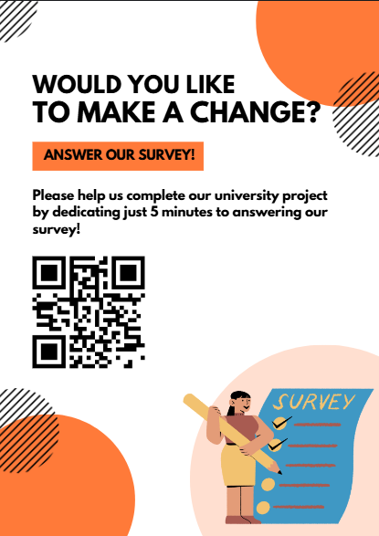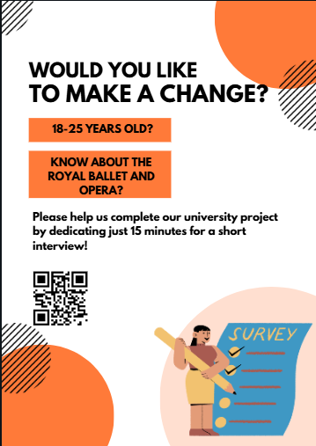

Appendix I: JASP Outputs

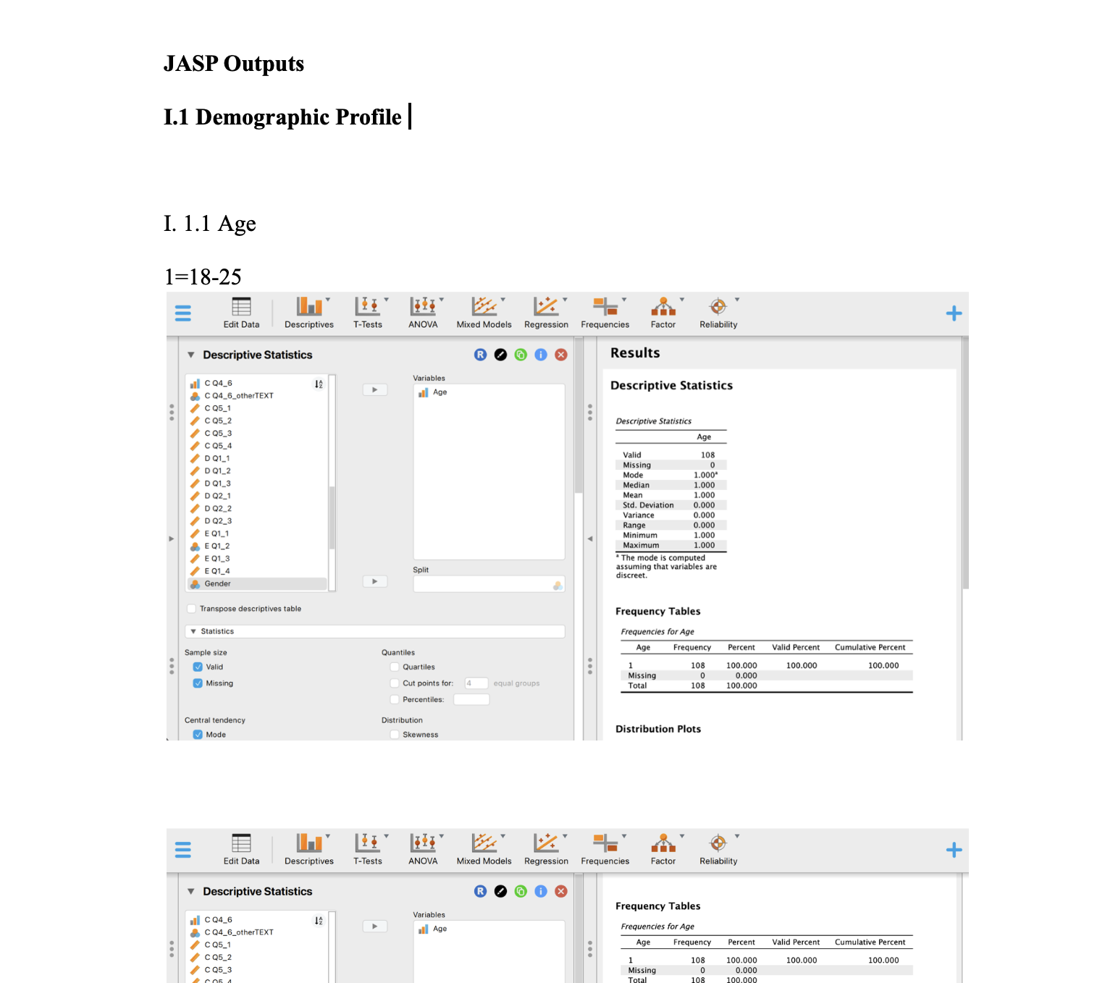
Link to full JASP output dataset here

Appendix J: Storyboard for Video Campaign

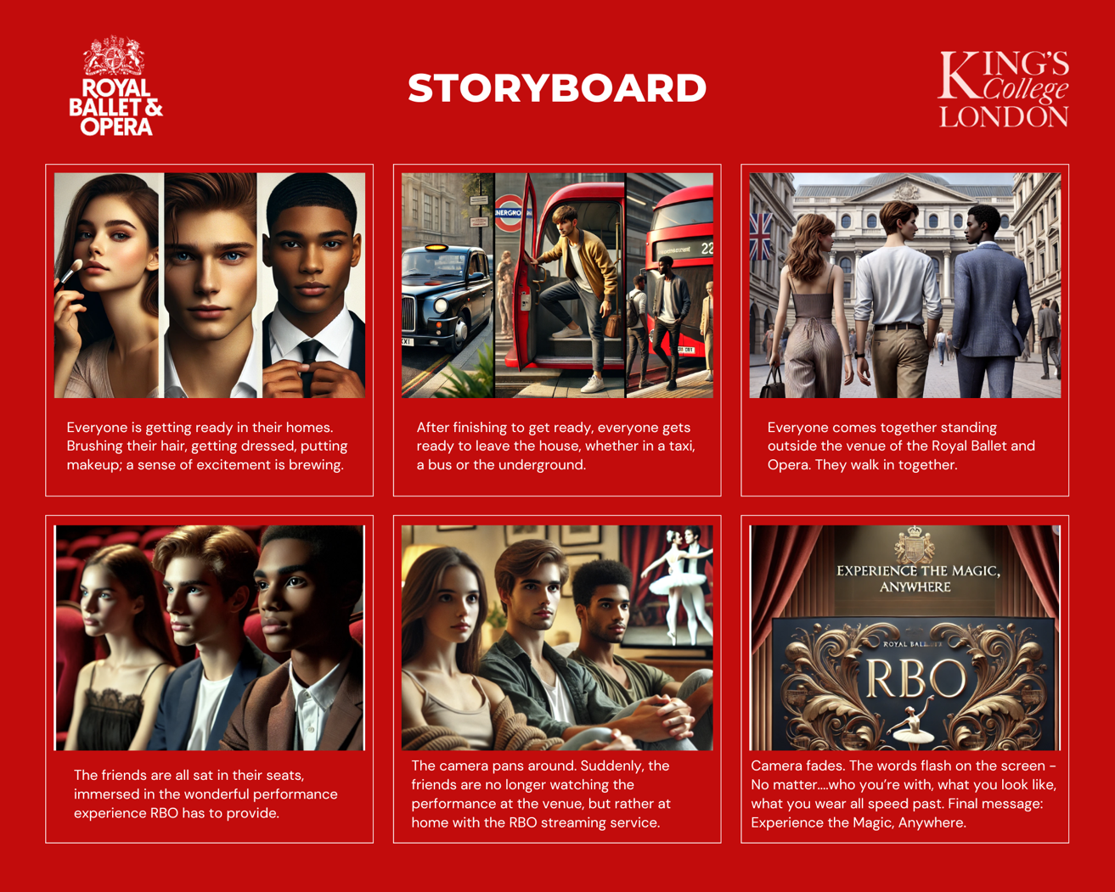
Images 1-6: AI-generated storyboard for the Royal Ballet & Opera (RBO), created using ChatGPT.

The storyboard depicts three friends, excited and ready for a new experience. Separately, they get ready, put on their best outfits, and make their way to meet each other. Standing outside the Royal Ballet and Opera, they are breathless; the grandeur and elegant architecture of the RBO venue was enough to be mesmerised. Followed by an enchanting performance, the friends are enthralled in the experience. The camera pans around, and the three friends are still sat, unable to take their eyes off the performance. Except, this time, they are at home, watching the performance on the Royal Ballet and Opera’s streaming service. You truly can experience the magic, anywhere.

Appendix K: Social Media Mock-up
Instagram Specific
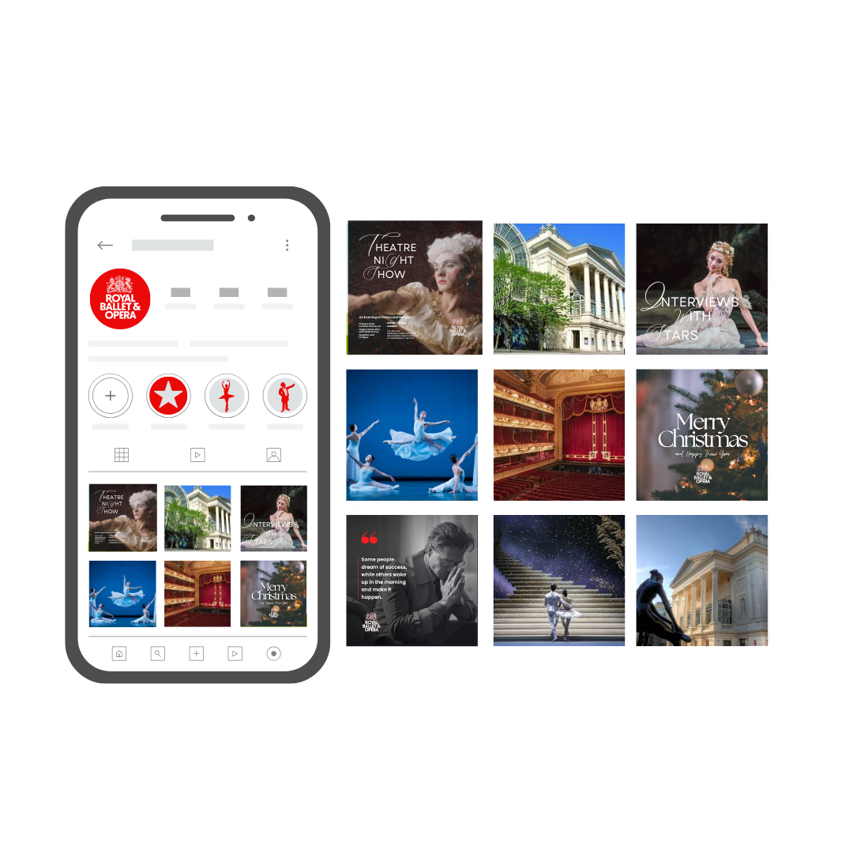

Appendix L: Cinema Ad Mock-up
Mockup of advertisements in cinemas.

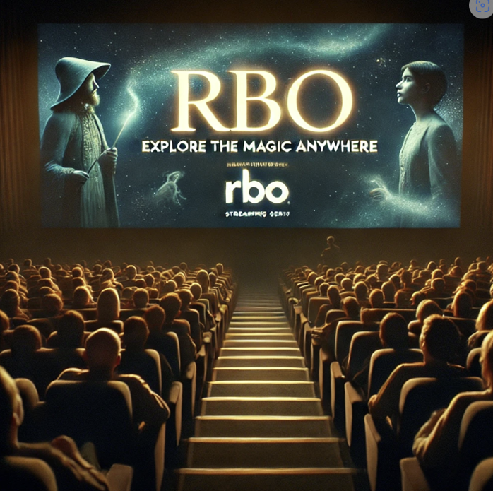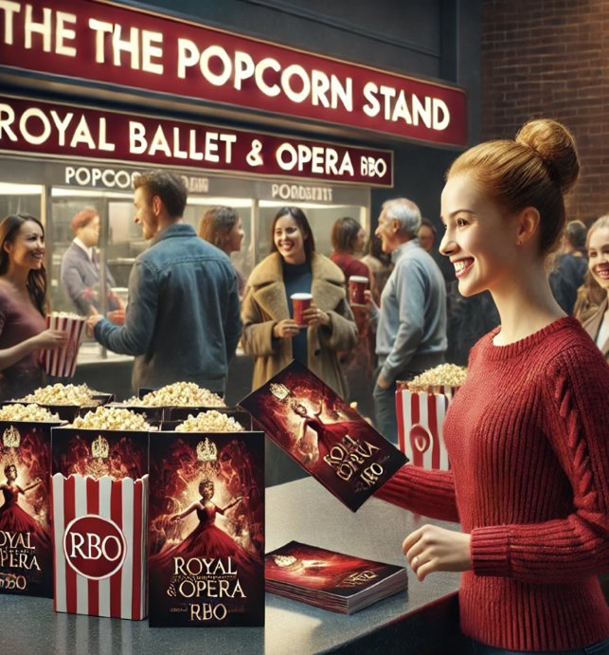
Image 1&2: AI-generated promotional materials for the Royal Ballet & Opera (RBO), created using ChatGPT.

An advertisement for RBO's streaming service being displayed on the screen in a movie theater just before the movie starts. The screen features the tagline "Explore the magic anywhere’.

Appendix M: Image Campaign
Image Campaign – online and offline media
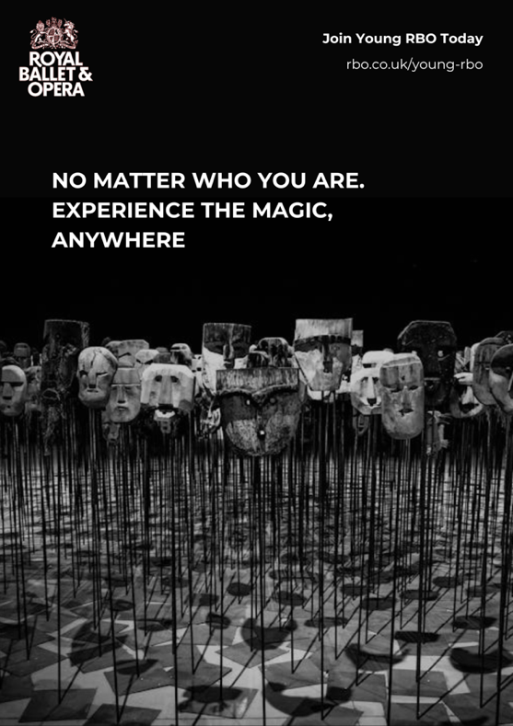
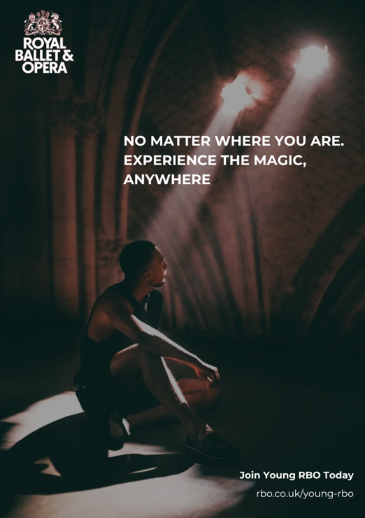
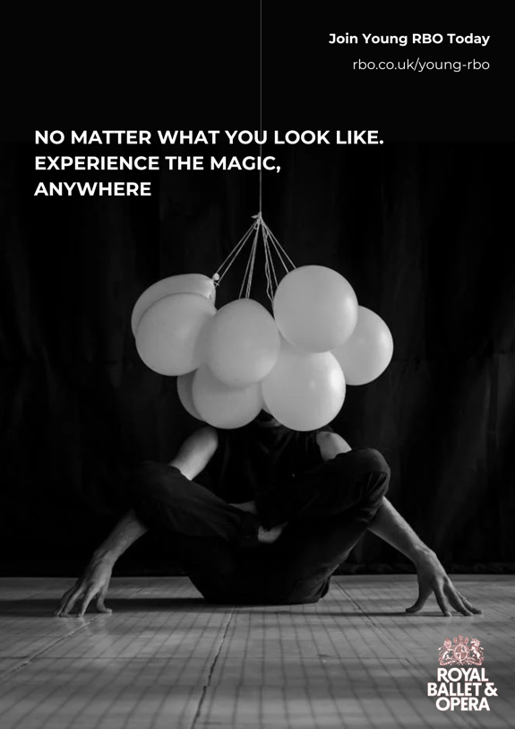
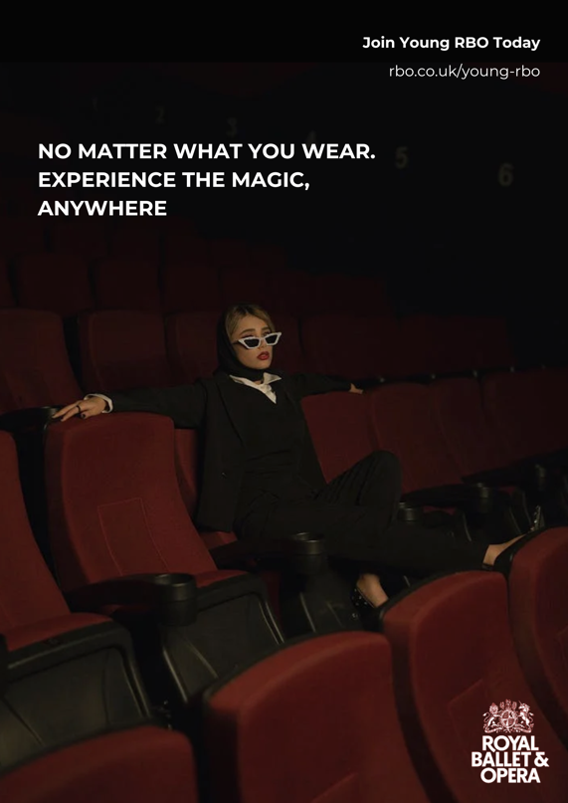
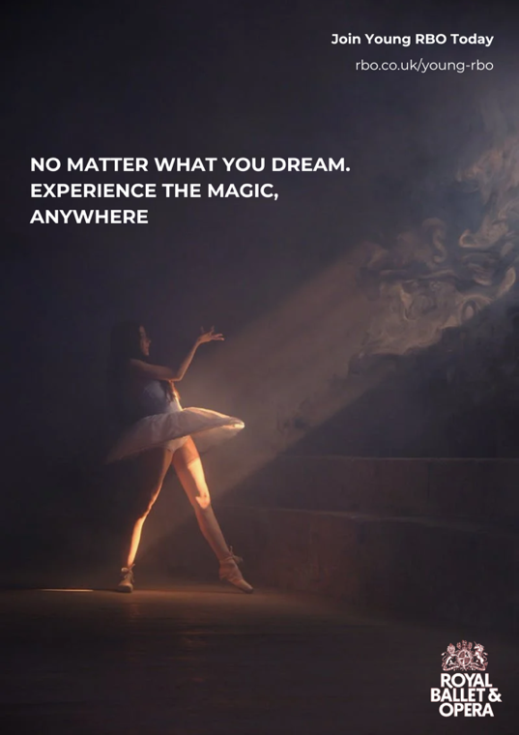
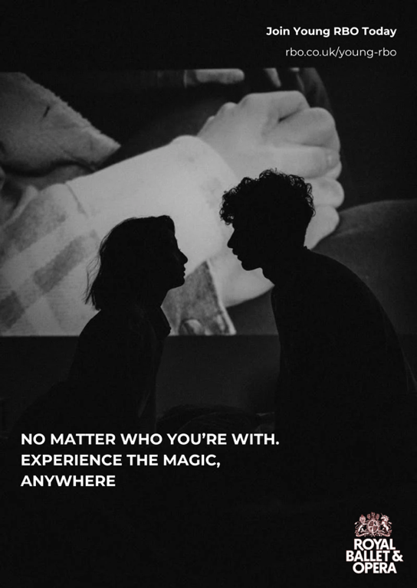

Appendix N: Market Positioning Table

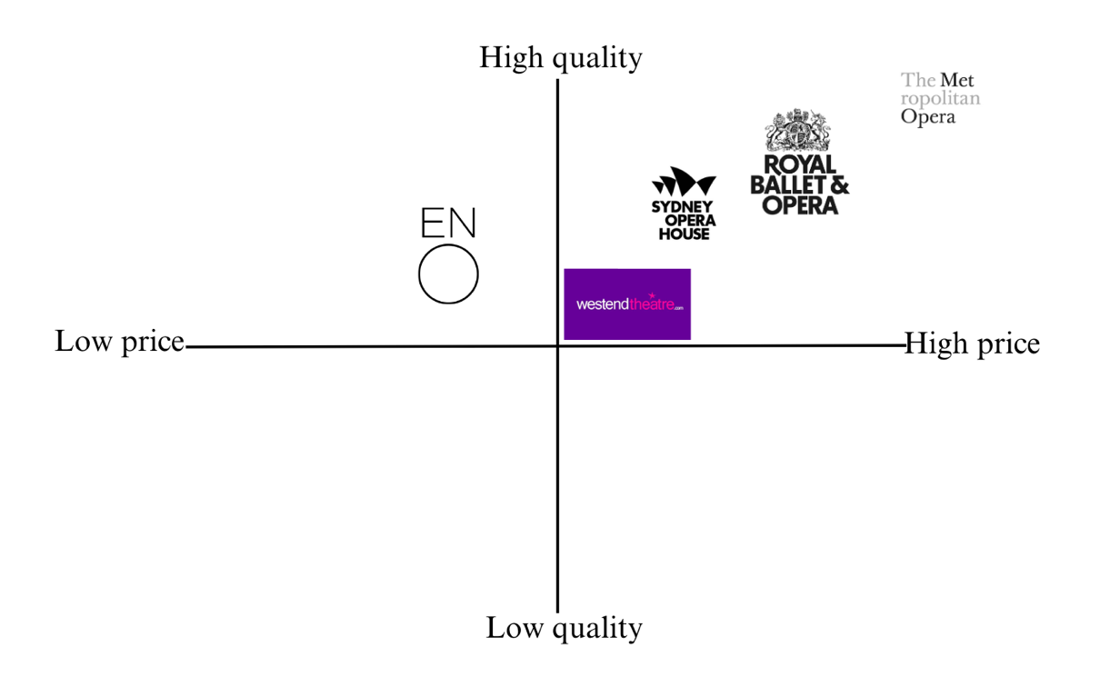
Figure: Market positioning table for RBO against within the competitive landscape

